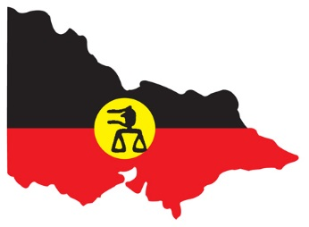
VICTORIAN ABORIGINAL LEGAL SERVICE
MEDIA RELEASE
Monday August 31
Senate Standing Committee on Finance and Public Affairs
Report on Domestic Violence in Australia
Aboriginal Legal Services Unsupported in Fight Against Domestic Violence
FOR IMMEDIATE RELEASE
The Victorian Aboriginal Legal Service is disappointed that a recent Federal Government does not include recommendations to support Aboriginal Legal Services in the fight against domestic violence.
The Senate Standing Committee on Finance and Public Affairs report, released on 20 August, includes 25 recommendations, none of which include support for increased funding for Aboriginal Legal Services. This includes both legal representation for victims, and support for offenders.
There is a significant connection between family violence and child protection – as shown by file reviews from Taskforce 1000 (review of files for Aboriginal children in out of home care). Victorian Aboriginal child substantiation rate is 68.6 per 1000 – the highest rate per 1000 in Australia. Many of these substantiations are due to ongoing domestic violence in the household.
Aboriginal children in Victoria are 9.4 times more likely to be substantiated than non-Aboriginal children in Victoria. If we can’t address family violence, over-representation of Aboriginal children in the child protection system will continue to grow.
In 2006-07, approximately 73% of all reports of Aboriginal domestic violence were attributed to repeat offenders. In 2012-13, this had increased to approximately 77% of all reports. It is essential that programs be put in place to ensure that recidivism does not occur.
The Victorian Aboriginal Legal Service is a member of the Victorian Indigenous Family Violence Partnership which developed the 10 year plan, ‘Strong Culture, Strong Peoples, Strong Families: Towards a safer future for Indigenous families and communities’ in 2008. However, without adequate federal funding, such a plan is difficult to implement.
The current Royal Commission into Family Violence in Victoria demonstrates the severity and frequency of domestic violence in the state. The impacts of domestic violence on Aboriginal communities is even more severe. That the federal government overlooked recommendations relating to legal representation and support for Aboriginal communities is a shameful oversight.
Quotes attributable to Wayne Muir, CEO of the Victorian Aboriginal Legal Service:
“I call on the federal and state governments to take heed of the various reports and data in this space properly fund the legal assistance sector.
FOR MORE INFORMATION:
Alister McKeich - Victorian Aboriginal Legal Service
03 9418 5999 amckeich@vals.org.au

