[](http://apnarm.com.au/)

**about arm**

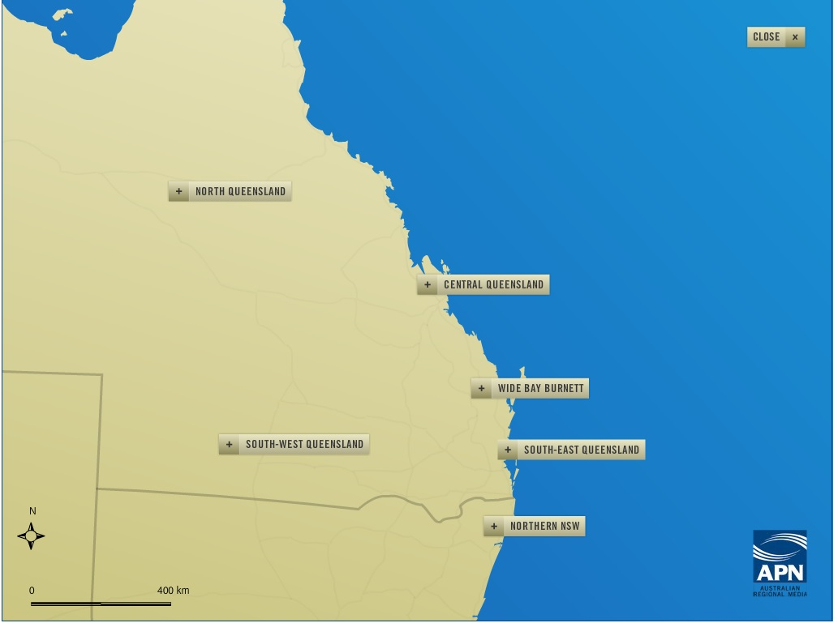

Our leading regional brands span across booming Australian regions - from Mackay in North Queensland to Coffs Harbour in Northern New South Wales.

At the heart of our success is our commitment to creating the most relevant and engaging local content across print and digital channels to inform and entertain our readers. We are extremely proud of the bonds we have built with our communities that have made our mastheads an integral part of the community for over 150 years.

With a publishing footprint from Coffs Harbour to Mackay, Australian Regional Media connects with over 1.5 million consumers every week, providing the perfect channel to connect with regional audiences.

We produce

* [12 daily newspapers](http://apnarm.com.au/newspapers/daily/)
* More than [60 community newspapers](http://apnarm.com.au/newspapers/community/) and [non-daily publications](http://apnarm.com.au/newspapers/special/)
* Over [30 regional news websites](http://apnarm.com.au/digital/)

Our daily newspapers

[Mackay - The Daily Mercury](http://www.dailymercury.com.au/)  
[Rockhampton - The Morning Bulletin](http://www.themorningbulletin.com.au/)  
[Gladstone - The Observer](http://www.gladstoneobserver.com.au/)  
[Bundaberg - The NewsMail](http://www.news-mail.com.au/)  
[Fraser Coast - The Fraser Coast Chronicle](http://www.frasercoastchronicle.com.au/)  
[Gympie - The Gympie Times](http://www.gympietimes.com.au/)  
[Sunshine Coast - The Sunshine Coast Daily](http://www.sunshinecoastdaily.com.au/)  
[Ipswich - The Queensland Times](http://www.qt.com.au/)  
[Toowoomba - The Chronicle](http://www.thechronicle.com.au/)  
[Warwick - The Warwick Daily News](http://www.warwickdailynews.com.au/)  
[Lismore/Northern Rivers - The Northern Star](http://www.northernstar.com.au/)  
[Grafton/Clarence Valley - The Daily Examiner](http://www.dailyexaminer.com.au/)

Our non-daily newspapers

[Airlie Beach - The Whitsunday Times](http://www.whitsundaytimes.com.au/)  
[Airlie Beach - The Whitsunday Coast Guardian](http://www.whitsundaycoastguardian.com.au/) [Biloela - The Central Telegraph](http://www.centraltelegraph.com.au/)[Emerald - The Central Queensland News](http://www.cqnews.com.au/)[Central / North Burnett - The Central & North Burnett Times](http://www.centralnorthburnetttimes.com.au/)  
[Childers - Isis Town & Country](http://www.isistcnews.com.au/)[Noosa - Noosa News](http://www.noosanews.com.au/)[Coolum - The Coolum & North Shore News](http://www.coolum-news.com.au/)[Sunshine Coast Hinterland - The Range News](http://www.rangenews.com.au/)[Caboolture - The Caboolture News](http://www.caboolturenews.com.au/)[Logan - The Reporter](http://www.thereporter.com.au/)[East Ipswich/West Brisbane - The Satellite](http://www.thesatellite.com.au/)[Ipswich - The Ipswich Advertiser](http://www.ipswichadvertiser.com.au/)[National - Big Rigs](http://www.bigrigs.com.au/)[Gatton - The Gatton, Lockyer and Brisbane Valley Star](http://www.gattonstar.com.au/)[Stanthorpe - The Stanthorpe Border Post](http://www.stanthorpeborderpost.com.au/)  
[Kingaroy - The South Burnett Times](http://www.southburnetttimes.com.au/)  
[Surat Basin - The Surat Basin News](http://www.suratbasin.com.au/)  
[St George - The Balonne Beacon](http://www.balonnebeacon.com.au/)  
[Chinchilla - The Chinchilla News](http://www.chinchillanews.com.au/)  
[Dalby - The Dalby Herald](http://www.dalbyherald.com.au/)  
[Charleville - The Western Times](http://www.westerntimes.com.au/)  
[Roma - The Western Star](http://www.westernstarnews.com.au/)  
[Tweed - Tweed Daily News](http://www.tweeddailynews.com.au/)[Ballina - Ballina Shire Advocate](http://www.ballinaadvocate.com.au/)[Byron Bay - The Byron Shire News](http://www.byronnews.com.au/)[Northern Rivers - The Northern Rivers Echo](http://www.echonews.com.au/)[Coffs Harbour - The Coffs Coast Advocate](http://www.coffscoastadvocate.com.au/)[Rural Weekly](http://www.ruralweekly.com.au/)

**DIGITAL**

With many brands in the market for over 100 years, we represent the 'local voice' of our communities and the trusted source of news and information. With strong loyalty to these brands, our regional audience is unique to our network.



|  |  |  |
| --- | --- | --- |
|  | **Desktop\*** | **Mobile\*** |
| Unique Visitors | 1,757,697 | 2,220,457 |
| Page Views | 9,628,416 | 7,001,149 |
|  |  |  |

**Mackay**

**Daily Mercury**

Having provided timely and relevant news to the diverse Mackay region for over 140 years, the award-winning [Daily Mercury](http://www.dailymercury.com.au/) has gained a large and devoted community following. Described as a strong local voice, the Daily Mercury mirrors the people of Mackay and continues to prosper, and remains the sole daily newspaper dedicated to this booming, resource-rich area. The Daily Mercury also features the popular [Rural Weekly North & Central Queensland edition](http://apnarm.com.au/newspapers/special/4609.html) every Friday.

* an average issue of the Daily Mercury is read by 39% of Mackay residents Monday to Friday*\*\**
* the Daily Mercury reaches 108,000 people each week through print and online channels *†*

[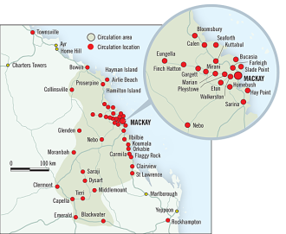](http://apnarm.com.au/media/Publication/cache/R5650-Daily_Mercury.png)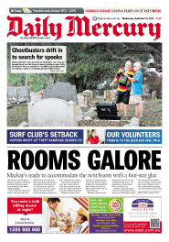

**Facts**

Published: Daily, Mon - Sat

Cover Price: $1.50 Mon – Fri; $1.80 Sat

Readership: 42,000 Mon - Fri; 36,000 Sat

Circulation: 8,826 Mon – Fri; 9,717 Sat

Sections: Real Estate; Commercial Property; Motoring; The Guide; Sport Junior Sport; Jobs; Better Business; Easy Eating; Smarter Shopping; Great Weekend; Rural Weekly (North CQ edition)

<http://www.dailymercury.com.au/> Monthly Unique Visitors: 247,000+

**Rockhampton**

**The Morning Bulletin**

Established in 1861, [The Morning Bulletin](http://www.themorningbulletin.com.au/) has provided the diverse Rockhampton region with reliable, locally-driven news and entertainment for 150 years. As the only local daily newspaper dedicated to the area, the popular title has long been considered an inherent feature of community culture, and is loved by its readers. The Morning Bulletin continually proves itself to be as prosperous and progressive as the dynamic region it serves.

* an average Monday to Saturday issue of The Morning Bulletin is read by 38% of Rockhampton residents*\*\**
* The Morning Bulletin reaches 118,000 people each week through print and online channels*†*

[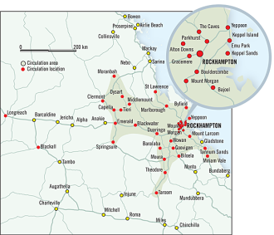](http://apnarm.com.au/media/Publication/cache/R5650-The_Morning_Bulletin.png)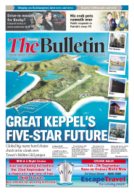

**Facts**

Published: Daily, Mon - Sat

Cover Price: $1.50 Mon – Fri; $1.90 Sat

Readership: 41,000 Mon – Fri*;* 39,000 Sat*\**

Circulation: 10,340 Mon – Fri*;* 13,890 Sat

Section: Real Estate; Commercial Property Motoring; Explore; The Guide; Sport; Jobs; Better Business; Easy Eating; Smarter Shopping; Weekend Buzz; Rural Weekly (Central Qld. edition)

<http://www.themorningbulletin.com.au/> Monthly Unique Visitors: 326,000+

**Gladstone**

**The Observer**

[The Observer](http://www.gladstoneobserver.com.au/) has remained an integral part of the Gladstone community for more than 140 years, providing locally-driven information and entertainment that successfully caters to the diverse interest of locals and tourists alike. As the city's sole daily newspaper, The Observer adheres to its "local news comes first" adage, combining a vibrant mix of news, events, opinions, lifestyle and travel features that reflect the local community.

* an average Monday to Friday issue of The Observer is read by 43% of Gladstone residents*\*\**
* The Observer reaches an audience of 71,000 each week across our print and digital platforms*†*

[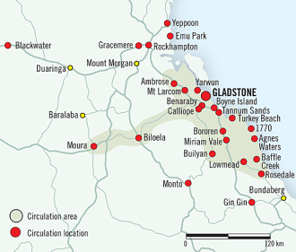](http://apnarm.com.au/media/Publication/cache/R5650-1_The_Observer.png)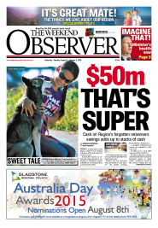

**Facts**

Published: Daily, Mon - Sat

Cover Price: $1.50 Mon – Fri; $1.70 Sat

Readership: 21,000 Mon – Fri*;* 18,000 Sat

Circulation: 4,306 Mon – Fri*;* 5,547 Sat

Section: Real Estate; Commercial Property; Weekend; Motoring; The Guide; Sport; Junior Sport; Jobs; Better Business; Easy Eating; NiE

<http://www.gladstoneobserver.com.au/> Monthly Unique Visitors: 241,000+

**Bundaberg**

**NewsMail**

Emerging as Bundaberg’s sole daily newspaper in 1938, the [NewsMail](http://www.news-mail.com.au/) has acquired a reputation for dependable, community-focused reporting, and continues to satisfy the city’s growing population. Catering to the needs of its readers and the city it services, the NewsMail includes a range of specialty sections that reflect the progressive Bundaberg community, including Bundy Buzz and FDF – Fishing, Diving, Four-Wheel Driving. The NewsMail also features the popular [Rural Weekly Wide Bay edition](http://apnarm.com.au/newspapers/special/4623.html) every Thursday.

* An average Monday to Friday issue of the NewsMail is read by 43% of Bundaberg residents, while the popular Saturday edition is read by 45% *\*\**
* the NewsMail reaches an audience of 95,000 each week across our print and digital platforms *†*

[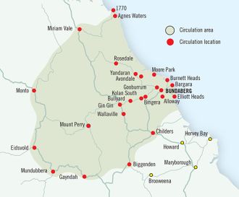](http://apnarm.com.au/media/Publication/cache/R5650-NewsMail.png)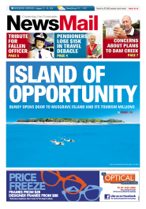

**Facts**

Published: Daily, Mon - Sat

Cover Price: $1.50 Mon – Fri; $1.90 Sat

Readership: 34,000 Mon – Fri*;* 36,000 Sat

Circulation: 6,964 Mon – Fri;*;* 10,204 Sat

Section: Real Estate; Commercial Property; Motoring; Weekend; Explore; The Guide; Sport; Junior Sport; Jobs; Better Business; Easy Eating; Rural Weekly (Wide Bay edition)

<http://www.news-mail.com.au/> Monthly Unique Visitors: 250,000+

**Fraser Coast**

**Fraser Coast Chronicle**

The [Fraser Coast Chronicle](http://www.frasercoastchronicle.com.au/) is the booming Fraser Coast region’s dedicated daily read. Featuring a vibrant mix of news and entertainment, the Fraser Coast Chronicle captures the holiday lifestyle of the region and includes coverage of local people, visitors, events, dining and business. The Fraser Coast Chronicle also features the popular [Rural Weekly Wide Bay edition](http://apnarm.com.au/newspapers/special/4623.html) and Let's Go Fishing supplements every week, an extensive lifestyle and entertainment section each weekend, and – vital to this high-growth area – a comprehensive property lift-out every Friday.

* an average Monday to Friday issue of the Fraser Coast Chronicle is read by 42% of all Fraser Coast residents, and the Saturday issue is read by 39% of the region*\*\**
* the Fraser Coast Chronicle reaches an audience of 80,000 each week across our print and digital platforms

[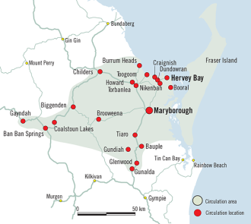](http://apnarm.com.au/media/Publication/cache/R5650-1_Fraser_Coast_Chronicle.png)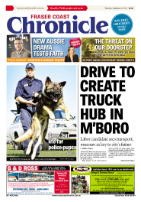

**Facts**

Published: Daily, Mon - Sat

Cover Price: $1.50 Mon – Fri; $1.60 Sat

Readership: 34,000 Mon – Fri*;* 27,000 Sat

Circulation: 6,299 Mon – Fri*;*  6,378 Sat*#*

Section: Real Estate; Commercial Property; Motoring; Explore; The Guide; Sport; Jobs; Better Business; Fraser Life; Easy Eating; Weekend; Let's Go Fishing; Rural Weekly (Wide Bay edition)

<http://www.frasercoastchronicle.com.au/> Monthly Unique Visitors: 191,000+

**Gympie**

**The Gympie Times**

Established in 1868 at the beginning of the region-defining Gympie Gold Rush, [The Gympie Times](http://www.gympietimes.com.au/) has long-since provided residents and visitors with in-depth coverage of local news, sport, people and events. After 145 years in print, the publication stands by its traditional community focus, but strives to continually evolve to reflect the prospering city it services. Featuring news from the country and around the world, The Gympie Times also includes a daily entertainment section, full-colour property guide, business and community pages, and Weekend – Saturday’s complete lifestyle and entertainment read.

* The Gympie Times is read by 44% of Gympie residents on weekdays, and almost one-half of locals each Saturday*\*\**
* The Gympie Times reaches an audience of 42,000 each week across our print and digital platforms*†*

[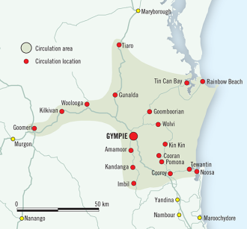](http://apnarm.com.au/media/Publication/cache/R5650-The_Gympie_Times.png)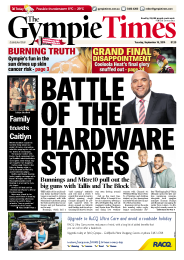

**Facts**

Published: Daily, Tue - Sat

Cover Price: $1.50 Tue – Fri; $1.70 Sat

Readership: 18,000 Tue – Fri*;* 19,000 Sat

Circulation: 3,438 Tue – Fri*;*  5,763 Sat

Section: Real Estate; Commercial Property; Motoring; Explore; The Guide; Sport; Jobs; Better Business; Easy Eating; Weekend; NiE; Rural Weekly (Wide Bay edition)

<http://www.frasercoastchronicle.com.au/> Monthly Unique Visitors: 91,000+

**Sunshine Coast**

**Sunshine Coast Daily**

The award-winning [Sunshine Coast Daily](http://www.sunshinecoastdaily.com.au/) directly mirrors the booming coastal region that it services. A vibrant and successful publication, the Sunshine Coast Daily reflects the dynamic growth and affluence of the coastal Queensland region. Catering to residents and visitors to one of Australia’s most popular areas, the Sunshine Coast Daily is a comprehensive daily read that features a number of high-quality supplements, including a full-colour, 80-plus page property guide.

* an average Monday to Friday issue of the Sunshine Coast Daily reaches 26% of people living on the Sunshine Coast*\*\**
* the Sunshine Coast Daily reaches an audience of 290,000 each month across our print and digital platforms*\**

[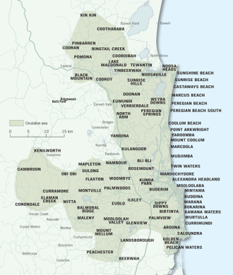](http://apnarm.com.au/media/Publication/cache/R5650-Sunshine_Coast_Daily_revised_Aug_2010.png)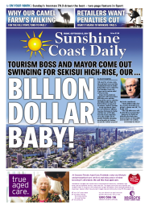

|  |  |
| --- | --- |
|  |  |

**Facts**

Published: Daily, Mon - Sat

Cover Price: $1.50 Mon – Fri; $2.00 Sat

Readership: 63,000 Mon – Fri*;* 58,000 Sat

Circulation: 11,725 Mon – Fri*;*  16,235 Sat*#*

Section: Real Estate; Commercial Property; Motoring; Explore; The Guide; Sport; Junior Sport; Jobs; Better Business; Easy Eating; Weekend; NiE

<http://www.frasercoastchronicle.com.au/> Monthly Unique Visitors: 787,000+

**Ipswich**

**QT - The Queensland Times**

As the state’s oldest surviving provincial newspaper, [The Queensland Times](http://www.qt.com.au/) has informed and entertained the diverse Ipswich region for over 155 years, and remains a local institution for the residents of Ipswich and surrounding areas. Described as a leader within the community, the affectionately titled ‘QT’ continues to prosper and evolve to reflect the progressive, high-growth city it serves – Ipswich is currently the 4th largest-growing area in Queensland*†*. The QT is a modern, vibrant daily newspaper that has been carefully designed and constructed to reflect the opinions and suggestions of its readers.

* an average weekday issue of the QT is read by over one-third of residents in the booming city of Ipswich*\*\**
* The QT reaches an audience of 117,000 each week across our print and digital platforms^^

[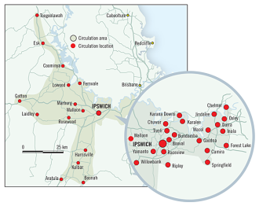](http://apnarm.com.au/media/Publication/cache/R5650-QT_The_Queensland_Times.png)

**Facts**

Published: Daily, Mon - Sat

Cover Price: $1.50 Mon – Fri; $1.90 Sat

Readership: 36,000 Mon – Fri;*;* 33,000 Sat

Circulation: 7,155 Mon – Fri*;* 8,587 Sat*#*

Section: Real Estate; Commercial Property; Motoring; Explore; The Guide; Sport; Junior Sport; Jobs; Better Business; Easy Eating; Weekend; NiE

<http://www.qt.com.au/> Monthly Unique Visitors: 353,000+

|  |  |
| --- | --- |
|  |  |

**Warwick**

**Warwick Daily News**

The [Warwick Daily News](http://www.warwickdailynews.com.au/) is dedicated to the unique Warwick audience, in the heart of the Darling Downs region. As the historic city’s only daily newspaper, Warwick Daily News has kept residents informed with local, national and international news for 150 years. Widely known as a credible and dependable local medium, the Warwick Daily News provides residents with up-to-date news, entertainment and consumer information, and also includes specialised sections for readers from Warwick’s surrounding shires. Warwick Daily News also features the [Rural Weekly South West Queensland edition](http://apnarm.com.au/newspapers/special/4648.html) every Friday.  The Bush Telegraph is featured every Tuesday - a weekly rural publication which also appears within The Stanthorpe Border Post.

* The Warwick Daily News reaches an audience of 32,000 each week across our print and digital platforms*\*\**
* This popular title is the widest read newspaper in the Warwick region^

[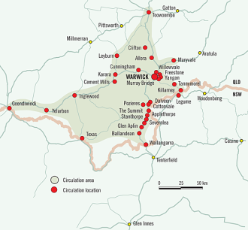](http://apnarm.com.au/media/Publication/cache/R5650-Warwick_Daily_News.png)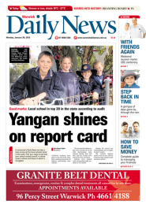

**Facts**

Published: Daily, Mon - Sat

Cover Price: $1.50 Mon – Fri; $1.70 Sat

Readership: 10,000 Mon – Fri; 8,000 Sat*\**

Circulation: 2,480 Mon – Fri*;* 2,355 Sat*#*

Section: Real Estate; Commercial Property; Motoring; Explore; The Guide; Sport; Jobs; Better Business; Easy Eating; Smarter Shopping; Weekend; NiE; Bush Telegraph; Rural Weekly (Southern edition)

<http://www.warwickdailynews.com.au/> Monthly Unique Visitors: 105,000

**Toowoomba**

**The Chronicle**

Since it was founded in 1861, [The Chronicle](http://www.thechronicle.com.au/) has upheld and strengthened a reputation for delivering quality, accurate and up-to-date reporting. Now an award-winning publication, The Chronicle remains the sole daily newspaper dedicated to the affluent, high-growth Toowoomba region. The Chronicle features a comprehensive mix of information and entertainment – including the [Rural Weekly South West Queensland edition](http://apnarm.com.au/newspapers/special/4648.html) each Friday – and is regarded as the primary source of news, views and advertising information for Toowoomba residents.

* Weekday editions of The Chronicle are read by 36% of the Toowoomba population; on Saturday, The Chronicle reaches 37% of residents*\*\**
* The Chronicle reaches an audience of 186,000 each week across our print and digital platforms*†*

[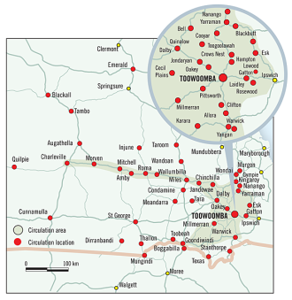](http://apnarm.com.au/media/Publication/cache/R5650-The_Chronicle.png)

**Facts**

Published: Daily, Mon - Sat

Cover Price: $1.50 Mon – Fri; $2.00 Sat

Readership: 57,000 Mon - Fri*\**; 59,000 Sat

Circulation: 15,529 Mon – Fri; 20,056 Sat*#*

Section: Real Estate; Commercial Property; Motoring; Explore; The Guide; Sport; Jobs; Better Business; Easy Eating; Smarter Shopping; Weekend; Diva; Rural Weekly (Southern edition)

<http://www.thechronicle.com.au/> Monthly Unique Visitors: 429,000+

**setting the agenda**

ARM Newsdesk comprises a team of senior journalists who produce compelling content for ARM’s stable of print and digital publications. As well as covering the big issues of the day, the Newsdesk journalists are the driving force behind ARM’s major campaigns including Terror at Home and Fair Go for our regions. The success of these campaigns rely on our ongoing access to community-based stakeholders and national and state-wide experts across political, legal, finance and business, education, environment, health, technology and many other areas.

**Terror at Home**

The Terror at Home Campaign, which has been running across ARM’s 12 regional daily newspapers since February 2015, helps shine the light on domestic violence and pushes governments to take immediate action to end the epidemic. Pressure from this campaign resulted in the Queensland Government rolling out respectful relationships programs in schools and putting in place domestic violence-specific courts, among other remedies.

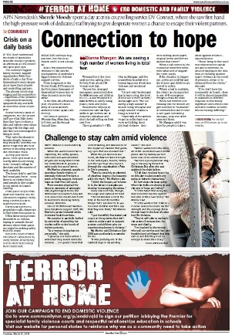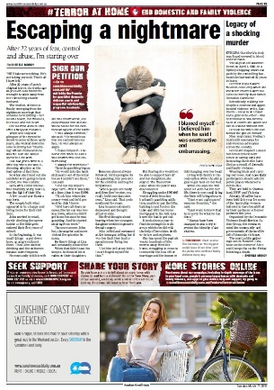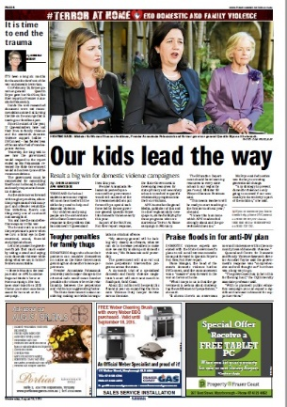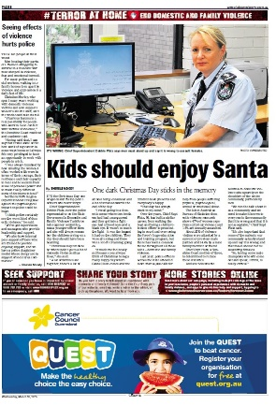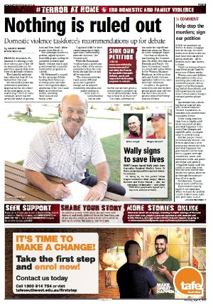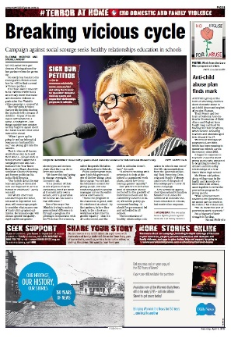

**Fair Go for Our Regions**

The Fair Go campaign is currently running across 23 Australian Regional Media mastheads as the nation heads to the polls. This special pre-election campaign pressures government for more support for regional areas. We’re wanting more strong major party commitments on jobs, incomes, health, aged care, low cost legal support and more.

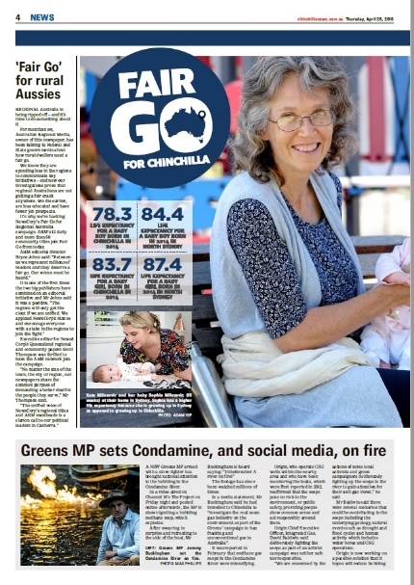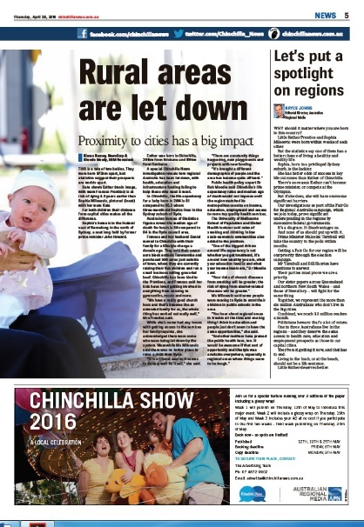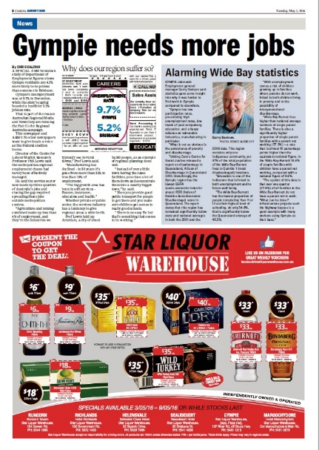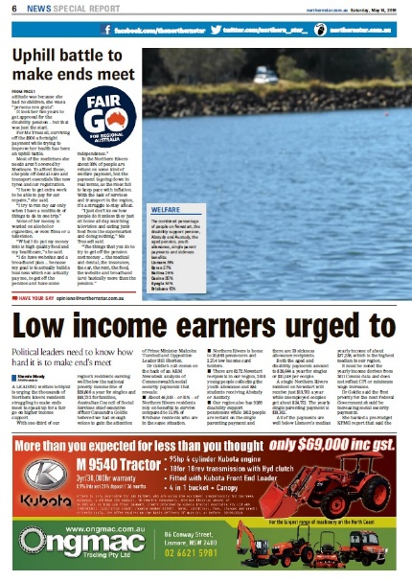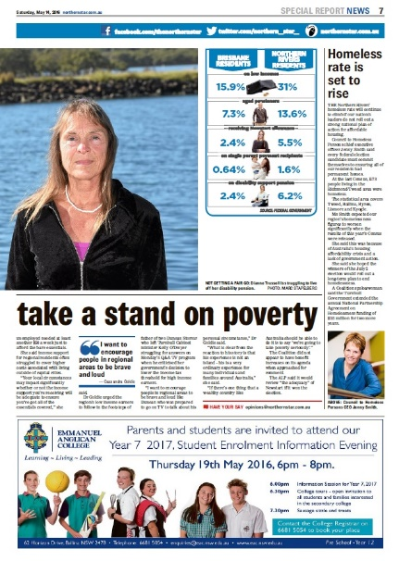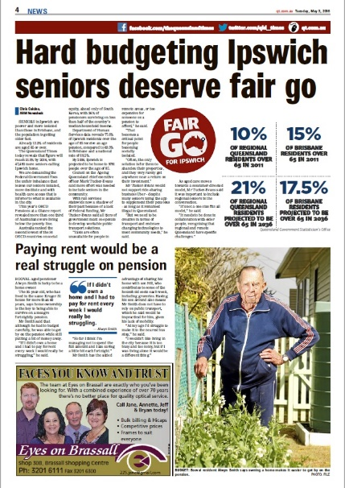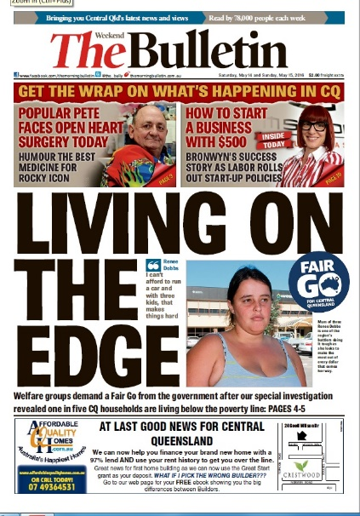

**Getting your message to our readers**

Local. Local. Local. Our editors demand high-quality localised news stories that engage their readers. In order to do this, it’s vital for organisations to provide regional spokespeople and where possible, the chance for our journalists to interview local residents about the issues of the day. When there is topic that resonates across our diverse readership, the ARM Newsdesk journalists rise to the challenge of getting localised takes on the story across our papers. For example, community legal centres are desperately trying to get the Turnbull Government to reverse looming funding cuts. This is how we covered the issue across our 10 Queensland regional daily newspapers:

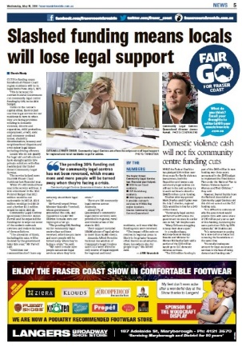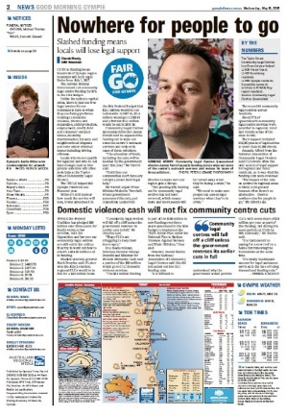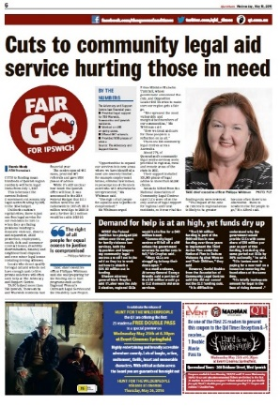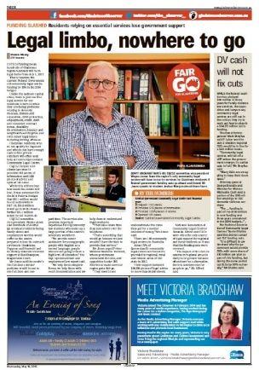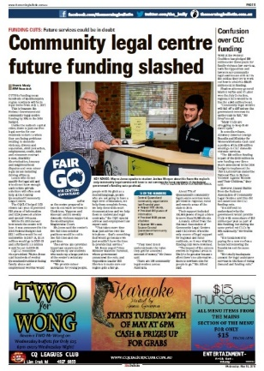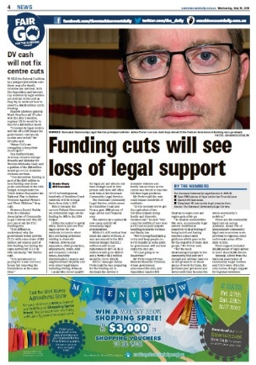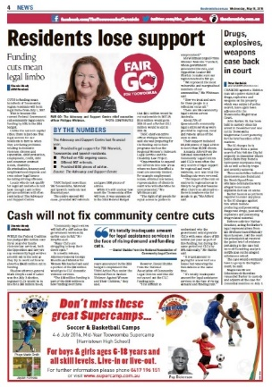

**engage with us**

Our newsrooms get hundreds of media releases every week. Some of these releases will lead to great coverage but others will fall by the wayside. The last thing you want is your media release to end up in the trash can. These are the secrets to making your presser stand out from the crowd.

**Headlines**

The more interesting the headline – and your email subject line – the better the chance you will attract our attention. Make the headline active, accurate and engaging. Here are some examples of great headlines.



**Keep your media release short, simple and to the point**

There’s an old rule of thumb in journalism – the first paragraph generally has the “who, what, when, where and why” of the story. Like all rules, this can be broken but it doesn’t hurt to use this concept as a starting point. Make sure your first paragraph tells the journalist the story. Then use the following sentences to provide the information that backs up your pitch. Keep your media release short, sharp, simple and to the point. Follow your emailed press release up with a phone call a few hours later. If you don’t get a bite, do not be afraid to the deputy editor or the chief of staff why they are not interested? Expect them to be forthright and feel free to use what they say to make your release stronger and more relevant.

**Facts and figures**

Nothing says local as well as region-specific facts and figures. The more information you give that’s focused on your pitch and on your community, the more likely you’ll entice the journalist to give you a call.

**Quotes and local contacts**

Journalists love local voices. Editors love local voices. Readers love local voices. Always make sure you, or someone from your organisation, is available to do interviews and be photographer. And if you can rustle up a local resident impacted by the topic of your press release, you’ll be on a sure-fire winner. Just make sure the talent can speak well (journalists do not want yes or no answers) and that they are available to be photographed on a pretty flexible timetable. Newsrooms are very busy and often only have limited spots available for photo shoots and interviews so you and your talent must be able to work within these constraints. It’s also important to realise that journalists are highly unlikely to show you their stories. However, you are more than welcome to ask that your quotes be read back to you.

**Can we reach you?**

Make sure you include mobile phone numbers for all of your talent. If journalists can’t reach potential interviewees they will struggle to write anything.

**When will my story be published?**

It’s always nerve-wracking waiting for your story to be published. Sometimes you will do an interview this week and the story will not appear until next week. It’s perfectly OK to ask your journalist when they expect the article to go to print. But it’s also important to remember that sometimes breaking news on major issues push non-timely stories out of the deadline cycle.