Community Legal Centre’s

Form filling training

**Invitation**

# Join Victim Assist Queensland for a *free* training session to gain an understanding of how to complete financial assistance application forms.

## WHEN: Wednesday 27 July 2016

**TIME: 9:30 – 11:30 am**

**WHERE: Training room, level 6, 154 Melbourne St South Brisbane (corner of Manning St)**

**COST: Free, coffee and tea provided**

**RSVP:** Places are limited. Please register your interest by contacting Lindsey Franklin-Browne, phone 3109 1937 or via email: [lindsey.franklinbrowne@justice.qld.gov.au](mailto:lindsey.franklinbrowne@justice.qld.gov.au).

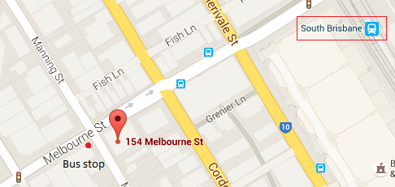**LOCATION:**