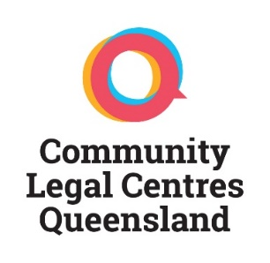

ANNUAL GENERAL MEETING AGENDA

**10:30am, Monday 10 October 2016**

**The Gardens Club**

**75 Gardens Point Road  
Brisbane City Botanic Gardens**

**1. CONFIRMATION OF PREVIOUS MINUTES**

**PROPOSED MOTION:** That the minutes of the 22 OCTOBER 2015 Annual General Meeting be accepted.

**PROPOSED MOTION:** That the minutes of the 11 NOVEMBER 2015 Special General Meeting be accepted.

**2. BUSINESS ARISING FROM AGM MINUTES (22 October 2015)**

**3. GENERAL REPORTS**

Presentation of Community Legal Centres Queensland Inc’s 2015-16 Annual Report.

**PROPOSED MOTION:** That the reports contained in the 2014-2015 Annual Report be accepted.

**4. FINANCIAL REPORT**

1. Presentation of Community Legal Centres Queensland Inc. audited financial report including statement of income and expenditure, assets and liabilities and mortgages, charges and securities affecting Community Legal Centres Queensland Inc. property for 2015-16.

**PROPOSED MOTION:** That the 2015-16 audited financial report be accepted.

1. Appointment of Auditor

**PROPOSED MOTION:** That the current auditor, **Haywards Chartered Accountants**, continue for the 2016-17 financial year

**5. PUBLIC LIABILITY INSURANCE COVER**

The Public liability insurance certificate of currency is held at the Community Legal Centres Queensland Inc office in Brisbane, Queensland. The current level of cover is $20,000,000 for the period 1 July 2016 to 30 June 2017.

**6. ELECTION OF MANAGEMENT COMMITTEE**

**PROPOSED MOTION:** That the Management Committee nominations be accepted and appointed to their nominated positions for 2016-2017.

**Meeting close …..am**

|  |  |  |
| --- | --- | --- |
| **SIGNED** |  | **DATE** |

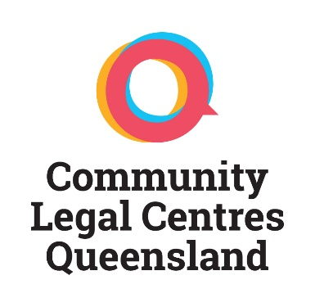

**MEMBERS**

|  |
| --- |
| Aboriginal Family Law Service Southern Queensland |
| Aboriginal & Torres Strait Islander Women’s Legal Services NQ Inc. |
| Basic Rights Queensland Inc. |
| Bayside Community Legal Service Inc. |
| Cairns Community Legal Centre Inc. |
| Care Goondiwindi Association Inc. (Goondiwindi Community Legal Service) |
| Caxton Legal Centre Inc. |
| Central Queensland Community Legal Centre Inc. |
| Gold Coast Community Legal Service Inc. |
| Environmental Defenders Office of Northern Queensland Inc. |
| Environmental Defenders Office (Qld) Inc. |
| Hervey Bay Neighbourhood Centre Inc. – Taylor Street Community Legal Service & SLASS |
| Junkuri Laka Wellesley Islands Aboriginal Law, Justice and Governance Association Inc. |
| Lesbian Gay Bisexual Trans Intersex Legal Service Inc. |
| Mackay Regional Community Legal Centre Inc. |
| Moreton Bay Regional Community Legal Service Inc. |
| North Queensland Women’s Legal Service Inc. |
| Nundah Community Support Group Inc. (Nundah Community Legal Service) |
| Encircle Ltd (Pine Rivers Community Legal Service) |
| Prisoners’ Legal Service Inc. |
| Queensland Advocacy Inc. |
| Queensland Indigenous Family Violence Legal Service Corporation |
| Queensland Public Interest Law Clearing House Inc. |
| Refugee and Immigration Legal Service Inc. |
| Robina Community Legal Service Inc. |
| South West Brisbane Community Legal Centre Inc. |
| Suncoast Community Legal Service Inc. |
| Tenants Queensland Inc. |
| The Advocacy and Support Centre Inc. |
| Townsville Community Legal Service Inc. |
| Women’s Legal Service Inc. |
| Youth Advocacy Centre Inc. |
| YFS Ltd |