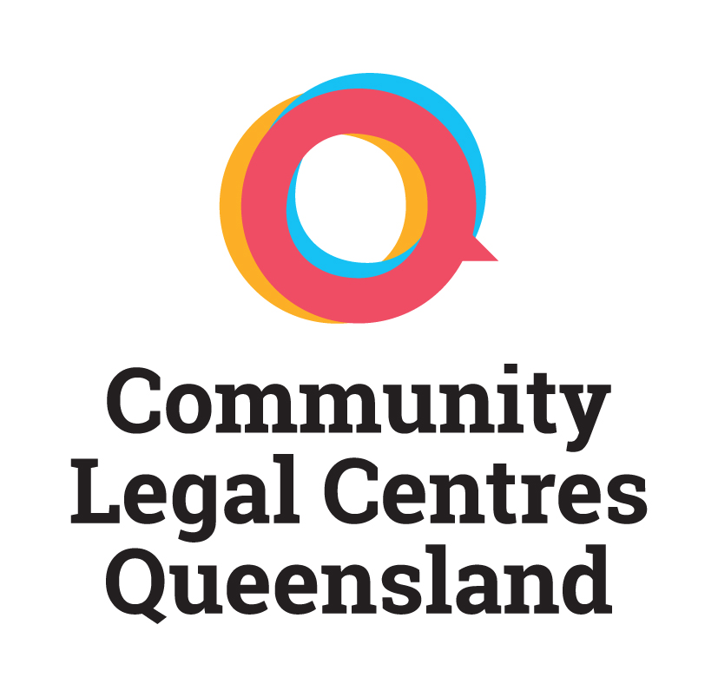

**2017 LEADERSHIP FORUM**

**Travel subsidy**

The annual Community Legal Centers Queensland workshop is one of the premier events in the community legal centre calendar. The workshop is an opportunity to develop and strengthen staff member skills, increase their knowledge base and network with people working in the field.

Community Legal Centres Queensland has allocated funding to bring ten community legal centre staff to the workshop. This year, as the event is being held in Townsville, the subsidy is available to centres that are located more than 200km from Townsville. The amount available is $300 per centre and can be used for travel or accommodation. Centres that are eligible to apply for to the scheme include:

|  |  |
| --- | --- |
| * Aboriginal Family Legal Service Southern Queensland * Basic Rights Qld * Bayside Community Legal Service * Cairns Community Legal Centre * Caxton Legal Centre * Central Queensland Community Legal Centre * Environmental Defenders Office Qld * Environmental Defenders Office of North Queensland * Gold Coast Community Legal Centre * Goondiwindi Community Legal Service * Junkuri Laka Community Legal Centre Aboriginal Corporation * Law Right * LGBTI Legal Service * Mackay Regional Community Legal Centre * Moreton Bay Regional CLS | * NQ Women’s Legal Service (Cairns) * Nundah Community Legal Service * Pine Rivers Community Legal Service * Prisoners Legal Service * Queensland Advocacy Inc. * Queensland Indigenous family Violence Legal Service * Refugee and Immigration Legal Service * Robina Community Legal Centre Inc. * South West Brisbane Community Legal Centre * Suncoast Community Legal Service * Taylor Street Community Legal Service * Tenants Queensland * TASC National * Women’s Legal Service * YFS Legal * Youth Advocacy Centre |

To apply for the funding, please complete details below and return to Community Legal Centers Queensland, by post or email.

If your centre is selected for funding you will then be asked to send Community Legal Centers Queensland an invoice for $300 and submit receipts within one month of the workshop taking place. The deadline for submitting applications is 1 October 2017.

|  |  |  |  |
| --- | --- | --- | --- |
|  |  |  | **COST** |
| **Organisation** |  |  |  |
| **Contact Person** |  |  |  |
| **Telephone** |  |  |  |
| **E-mail** |  |  |  |
| **Forward journey date & time** |  |  |  |
| **Return journey date & time** |  |  |  |
| **Travel details: e.g. from** |  |  |  |
| T**ype of travel: e.g. flight, car** |  |  |  |
| **Name and address of accommodation provider:** |  |  |  |
| **TOTAL COSTS** |  |  | $ |

Please forward this form by email to Hannah [admin@communitylegalqld.org.au](mailto:admin@communitylegalqld.org.au)

Post: Po Box 119, Stones Corner, QLD 4120. For further information phone 07 3392 0092.