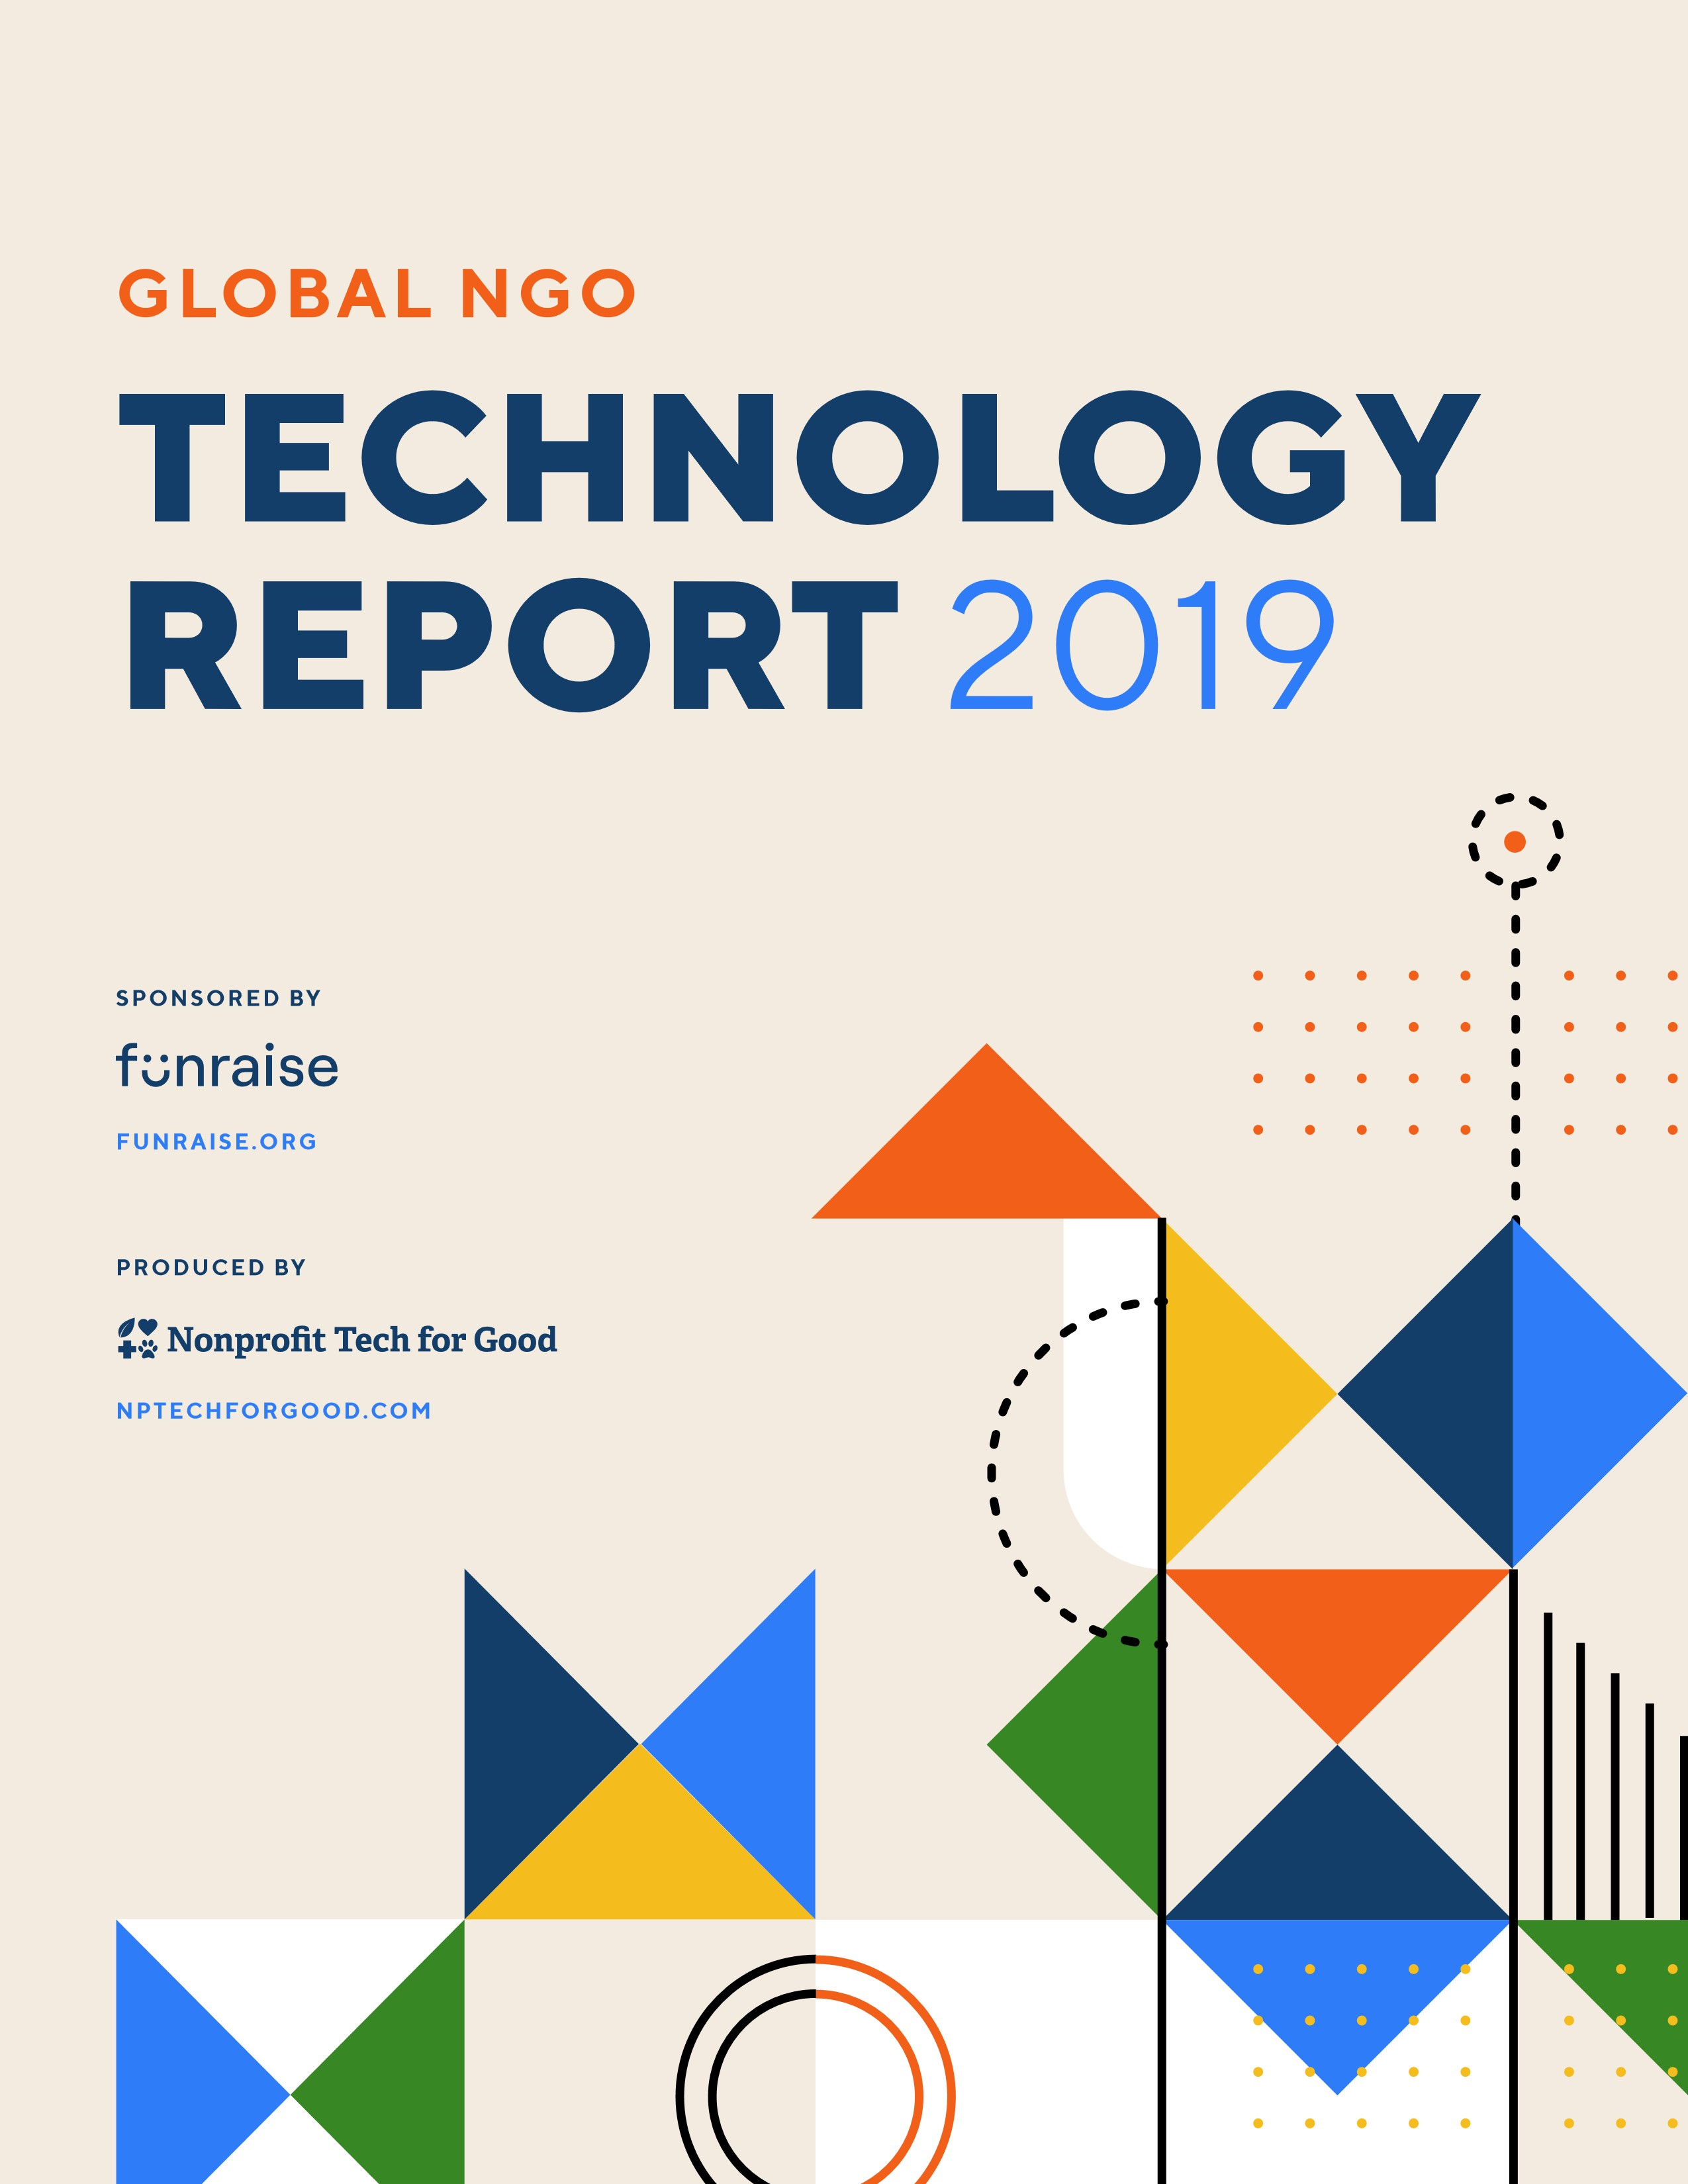

**Table of Contents**

**3**

**About the Report**

**NGO TECHNOLOGY BY REGION**

**4**

**Africa**

**8**

**Asia**

**12**

**Australia & New Zealand**

**16**

**Europe**

**20**

**Latin America**

**& the Caribbean**

**24**

**United States & Canada**

**31**

**Partners**

**NGO TECHNOLOGY WORLDWIDE**

**28**

**Benchmarks**

**30**

**Effectiveness Ratings**

**2**

**3 160**

# About the Report Countries

## 5,721

The Global NGO Technology Report is a biennial research project that **NGOs** seeks to gain a better understanding of how non-governmental organizations (NGOs) worldwide use technology. Sponsored by [**Funraise**](https://funraise.org/) and produced by [**Nonprofit Tech for Good**](https://www.nptechforgood.com/), the report examines how NGOs use web and email communications, online fundraising tools, social media, mobile technology, and productivity software.

Now in its fourth edition, this year’s report provides technology benchmarks for Africa, Asia, Australia and New Zealand, Europe, Latin America and the Caribbean, and the United States and Canada. A global average of the benchmark data—as well as Global NGO Technology Ratings—is also provided.

The Global NGO Technology Report is a sister report to the [**Global Trends in Giving Report**](https://funraise.org/techreport-past-reports). The findings from both reports are meant to help NGOs determine if they are effectively using technology to inspire philanthropy and achieve their mission

and programs.

### Methodology

The 2019 Global NGO Technology Report is based upon the survey results of 5,721 NGOs worldwide. The survey was promoted online from March 1, 2019 through May 31, 2019 and to reach a global audience, the survey was published in English, French, Portuguese, and Spanish. Due to the methodology used, it’s important to note that the results only represent the views of respondents that (1) read English, French, Portuguese, or Spanish; (2) have access to the Internet; and (3) use email and/or social media. Each year as more NGOs worldwide participate in the survey, the report becomes more accurate in its findings and useful to the NGO community.



[**FUNRAISE.ORG**](https://funraise.org/)

Funraise provides innovative and friendly fundraising technology built on a foundation of nonprofit experience. Our platform was built for fundraisers by fundraisers, helping you raise the funds and the fun.

[**NPTECHFORGOOD.COM**](https://www.nptechforgood.com/)

With nearly 50,000 monthly visitors and more than one million followers on social networks, Nonprofit Tech for Good is a leading online fundraising and social media blog for nonprofit professionals worldwide.

**N G O T E C H N O L O G Y I N**

# AFRICA

## About the Survey Respondents

### Top 5 Countries Top 10 Causes Type of Organization

|  |  |
| --- | --- |
| **Community development** | **15%** |
| **Education** | **12%** |
| **Health & wellness** | **11%** |
| **Women & girls** | **7%** |
| **Human & civil rights** | **4%** |
| **Human & social services** | **4%** |
| **Research & public policy** | **4%** |
| **Environment** | **3%** |
| **Peace & non-violence** | **3%** |

**Children & youth 20% Non-governmental**

**organization (NGO) 44%**

## 5% 38% 14% 3% 14%

**Ghana Nigeria**

**Kenya**

**Zambia**

**South**

**Africa**

### Top 5 Key Findings

**64% of NGOs in Africa accept credit card payments on their website, up from 50% in 2018. 28% accept mobile money and 5% accept cryptocurrency—both are higher rates than any other region.**

**1**

**2**

**3**

**4**

**5**

**#GivingTuesday is growing in Africa. 22% of NGOs participated in #GivingTuesday 2018, up from 17% in 2017. 64% raised more on #GivingTuesday 2018 than they did on #GivingTuesday 2017.**

**44% use WhatsApp to communicate with supporters and donors —16% above the global average. Of those, 81% find WhatsApp effective, 16% higher than the global average.**

**928**

**NGOs**

**40**

**Countries**

**87% use social media regularly and their strategy is advanced. 68% share Instagram Stories, 54% participate in Tweet Chats, 48% utilize Messenger bots, and 43% use YouTube Live.**

**African NGOs are embracing social advertising. Of those that use social media, 45% purchase Facebook Ads, 38% LinkedIn Ads, 37% Instagram Ads, 36% YouTube Ads, and 27% Twitter Ads.**

|  |  |
| --- | --- |
| **Non-profit organization (NPO)** | **27%** |
| **Charity** | **9%** |
| **Civil society organization (CSO)** | **7%** |
| **Religious organization** | **5%** |
| **Membership association** | **4%** |
| **Institution of higher education** | **3%** |
| **Grantmaking foundation** | **1%** |

**Size of Organization\***

## 16% 46%

**Large Small**

### 38%

#### Medium

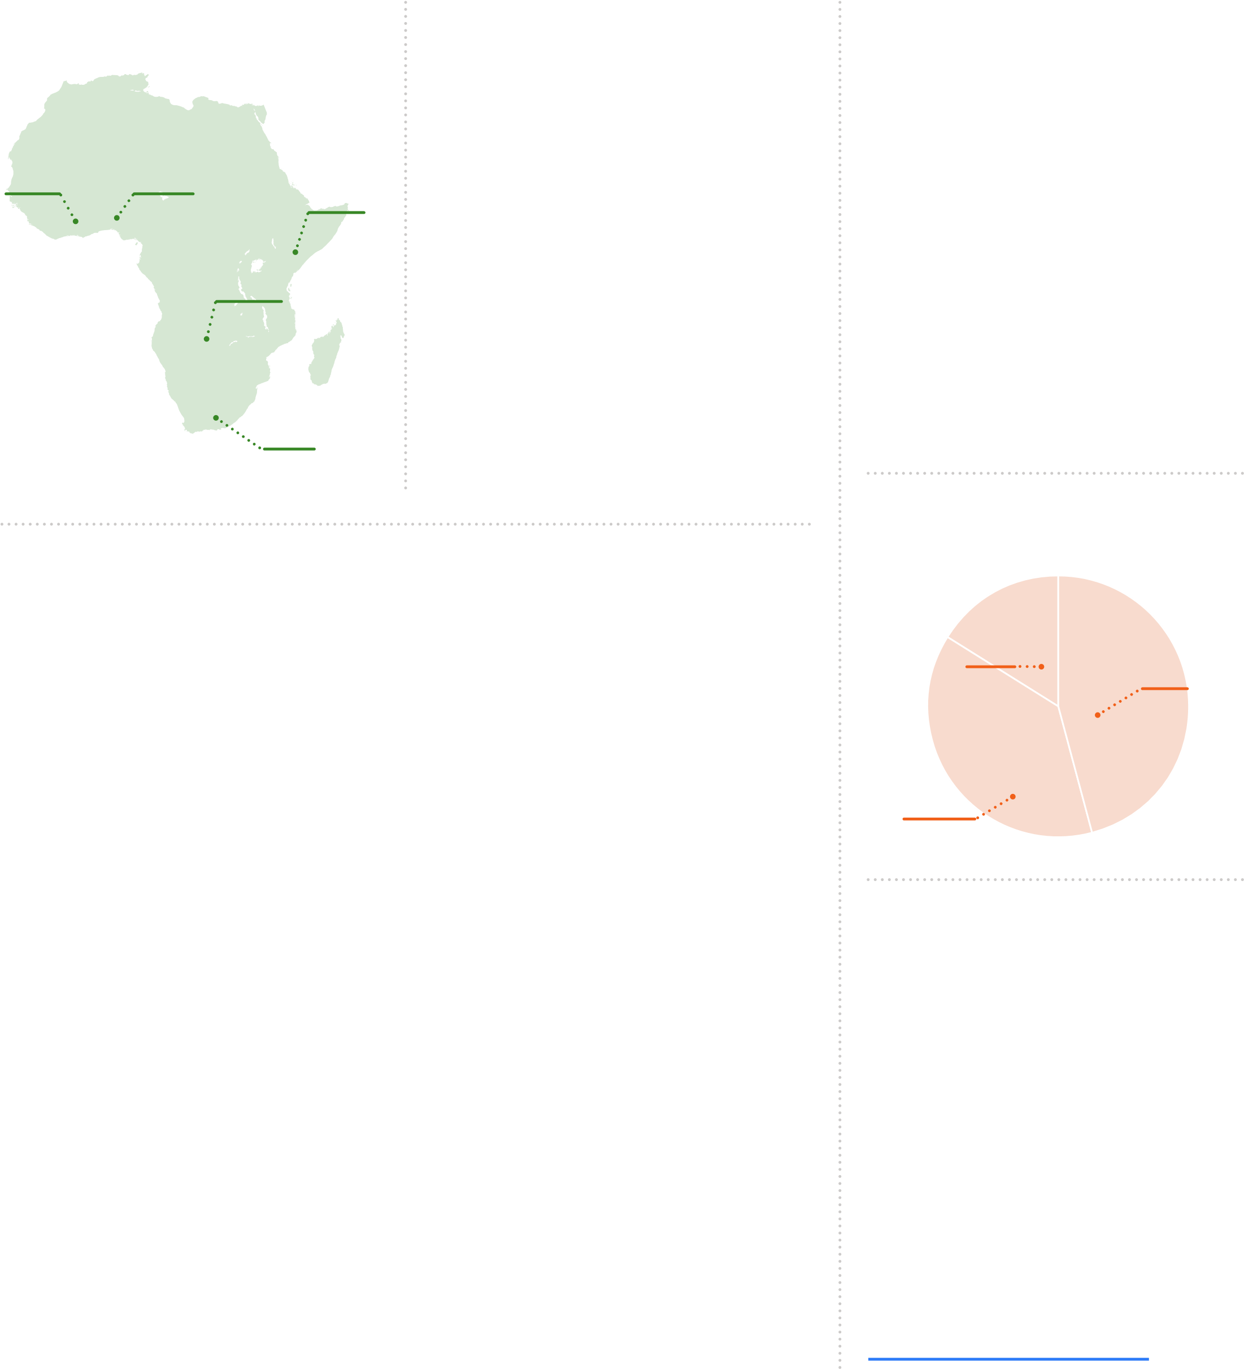**“NGOs should be paying close attention to advancements in machine learning and artificial intelligence. Both technologies will continue to transform how organizations communicate with their beneficiaries and funders—and in the process transform the workplace of the**

**Third Sector."**

*There is not an international standard of what defines an NGO as small, medium, or large, so survey respondents were asked to self-identify their NGO as small, medium, or large.

**OYEBISI BABATUNDE OLUSEYI,**

**EXECUTIVE DIRECTOR**

[**NIGERIA NETWORK OF NGOs**](https://nnngo.org/)

**Web & Email Communications**

# 61%

of NGOs in Africa have a website.

## WEBSITE FEATURES

**Mobile compatibility 89%**

|  |  |
| --- | --- |
| **SSL certificate** | **73%** |
| **Privacy policy** | **72%** |
| **Blog** | **55%** |
| **Event registration** | **50%** |
| **Online store** | **26%** |
| **Live chat** | **24%** |
| **Accessible to people with disabilities** | **19%** |

** 2018 Global NGO Technology Report

## Fundraising 63%

accept online donations on their website.

send email updates also send email

**66%** to their supporters. **57%** fundraising appeals.

**Quarterly 36%**

**8% Twice monthly Monthly 26%**

**8% Twice weekly Monthly 28% Weekly 12%**

**13% Daily**

**Quarterly 27%** Average number of

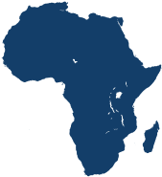**16% Weekly 5,298** email subscribers** **use a Customer Relationship Management 33% (CRM) software to track donations and manage communications with supporters and donors.**

**33% use encryption technology to protect their data and communications.\*\***

### TYPES OF PAYMENTS FUNDRAISING TOOLS USED

**Credit card 64% Recurring/monthly giving 47%**

**Direct debit 64% Crowdfunding 32%**

**Paypal 37% Mobile money 28%**

**Digital wallet 10% Peer-to-peer fundraising 28%**

**Cryptocurrency 5% Tribute giving 17%**

**Text-to-give 10%**

**Mobile card reader 8%**

## #GivingTuesday

**22%** of NGOs in Africa participated in #GivingTuesday 2018. Of those, 45% participated for the first time.

**64%** raised more on #GivingTuesday 2018 than they did on #GivingTuesday 2017.

**70%** of those that participated in #GivingTuesday 2018 plan to participate in #GivingTuesday 2019.

**Smart speaker giving 4%**

**Giving through gaming 3%**

**SHARE & FOLLOW**

Are you an expert on how NGOs in Africa use technology? Please share articles and blog posts with your analysis of the data for Africa using [**#NGOtech19**](https://twitter.com/hashtag/ngotech19) on social media.

[**Download Africa Data Separately**](https://go.funraise.io/tech-report-19-africa-download)

**6**

**Have a Facebook Page 94%**

Average number of

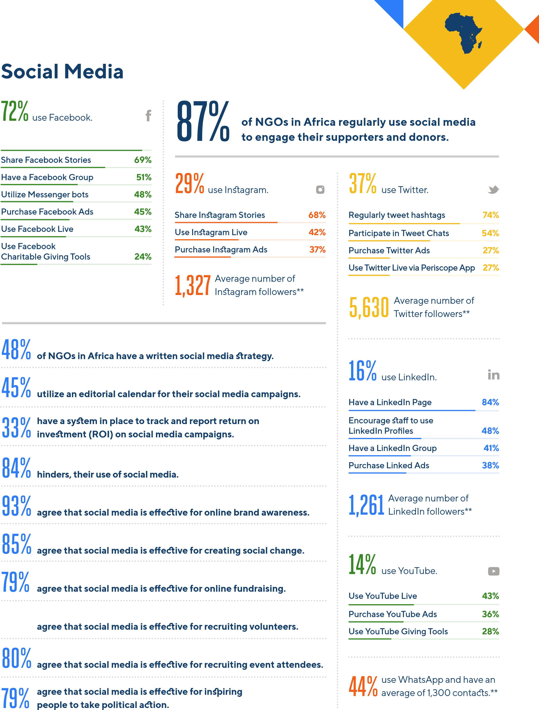**8,404** Facebook followers**

**say that their board helps, rather than**

## 81%

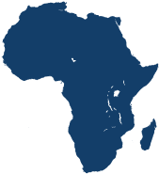

**Productivity & Emerging Technology**

**54**

**%**

of NGOs in Africa increased

spending on technology in 2019.

**%**

**13**

decreased spending.

**%**

**33**

made no change in their

technology budget from 2018.

**HOW WELL NGOs**

**UNDERSTAND**

**VERY**

**WELL**

**SOMEWHAT**

**WELL**

**NOT VERY**

**WELL**

**NOT**

**AT ALL**

**Artificial intelligence**

**%**

**37**

**%**

**30**

**23**

**%**

**%**

**10**

**Augmented reality**

**%**

**18**

**29**

**%**

**30**

**%**

**23**

**%**

**Blockchain technology**

**17**

**%**

**22**

**%**

**34**

**%**

**27**

**%**

**Cloud computing**

**%**

**32**

**29**

**%**

**%**

**26**

**%**

**13**

**Internet of Things**

**%**

**42**

**%**

**26**

**%**

**20**

**%**

**12**

**Machine learning**

**28**

**%**

**27**

**%**

**28**

**%**

**%**

**17**

**Predictive analytics**

**20**

**%**

**28**

**%**

**30**

**%**

**22**

**%**

**Virtual reality**

**31**

**%**

**31**

**%**

**%**

**22**

**16**

**%**

# 20% 19%

use an internal communications tool, such as Slack.

use an online project management tool, such as Asana.

# 35%

purchase Google Ads;

46% have a Google Ad Grant.

## Technology Effectiveness Ratings

The top 10 most effective communication and fundraising tools, according to NGOs in Africa:

**Social media 85%**

|  |  |
| --- | --- |
| **Website** | **85%** |
| **Case studies** | **80%** |
| **Annual reports** | **79%** |
| **Email updates** | **79%** |
| **Social media ads** | **74%** |
| **Email fundraising appeals** | **73%** |
| **Messaging apps** | **73%** |
| **Peer-to-peer fundraising** | **73%** |
| **Photo slideshows/essays** | **72%** |

**N G O T E C H N O L O G Y I N**

## ASIA

### About the Survey Respondents

#### Top 5 Countries Top 10 Causes

**Education 17%**

**Community development 16%**

**Children & youth 15%**

**India67% 6%**

**Health & wellness 9%**

**4~~%~~ Bangladesh Women & girls 9%**

**Pakistan Environment & conservation 8%**

**4% Human & social services 5%**

**Philippines Animals & wildlife 4%**

**Disability rights 3%**

**6**

**%**

**Malaysia Research & public policy 3%**

### Top 5 Key Findings

**67% of NGOs in Asia send email updates to supporters and donors, up from 55% in 2018. At 30%, most send email updates monthly. 56% also regularly send email fundraising appeals, 32% quarterly.**

**1**

**2**

**3**

**4**

**5**

**Compared to the global average, NGOs in Asia are leading in the use of new fundraising technology. 7% utilize smart speaker giving, 5% giving through gaming, and 4% cryptocurrency.**

**57% accept online donations on their website. 72% accept direct debit, up from 61% in 2018. 24% accept digital wallet payments, up from 11% in 2018. 31% accept PayPal, down from 36% in 2018.**

**95% agree that social media is effective, yet all use social media at rates lower than the global average. 72% use Facebook, 32% Twitter, 28% Instagram, 26% YouTube, and 25% LinkedIn.**

**56% increased their spending on technology in 2019, the highest rate worldwide. NGOs are embracing and investing in the digital revolution rapidly spreading throughout the Asian continent.**

**1,734**

**NGOs**

**40**

**Countries**

*There is not an international standard of what defines an NGO as small, medium, or large, so survey respondents were asked to self-identify their NGO as small, medium, or large.

#### Type of Organization

**Non-governmental**

**organization (NGO) 51%**

|  |  |
| --- | --- |
| **Non-profit organization (NPO)** | **26%** |
| **Civil society organization (CSO)** | **7%** |
| **Charity** | **5%** |
| **Religious organization** | **4%** |
| **Institution of higher education** | **3%** |
| **Grantmaking foundation** | **2%** |
| **Membership organization** | **2%** |

**Size of Organization\***

### 15% 45%

**Large**

**Small**

### 40%

#### Medium

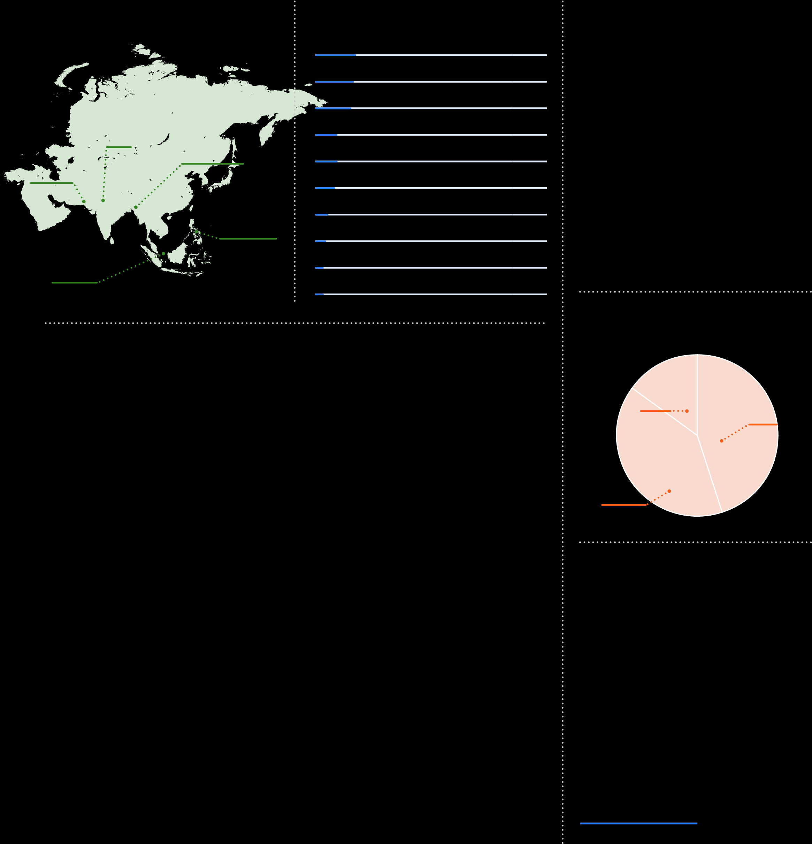**“As of 2019, India has 500 million mobile users and the largest youth population worldwide. Digital and demographic trends indicate that Indian NGOs will play key leadership roles in ushering in the next era of online engagement, fundraising, and mobile technology.”**

**BHOMIK SHAH, FOUNDER & CEO**

[**NGOBOX & CSRBOX (INDIA)**](https://ngobox.org/nb/index.php)

|  |
| --- |
| **Web & Email Communications** |

# 70%

of NGOs in Asia have a website.

## WEBSITE FEATURES

**Mobile compatibility 84%**

|  |  |
| --- | --- |
| **Privacy policy** | **68%** |
| **SSL certificate** | **58%** |
| **Event registration** | **53%** |
| **Blog** | **50%** |
| **Online store** | **25%** |
| **Live chat** | **20%** |
| **Accessible to people with disabilities** | **19%** |

** 2018 Global NGO Technology Report

## Fundraising 57%

accept online donations on their website.

send email updates also send email

**67%** to their supporters. **56%** fundraising appeals.

**4% Twice weekly Quarterly 32%**

**7% Twice monthly Monthly 27%**

**14% Weekly Monthly 30% Daily 15%**

**16% Daily Quarterly 29%** Average number of

**10,460** email subscribers**

**use a Customer Relationship Management 30% (CRM) software to track donations and manage communications with supporters and donors.**

**37% use encryption technology to protect their data and communications.\*\***

### TYPES OF PAYMENTS FUNDRAISING TOOLS USED

**Direct debit 72% Recurring/monthly giving 54%**

**Credit card 65% Crowdfunding 35%**

**Paypal 31% Peer-to-peer fundraising 28%**

**Digital wallet 24% Tribute giving 21%**

**Cryptocurrency 4% Text-to-give 13%**

**Mobile money 11%**

**Mobile card reader 9%**

## #GivingTuesday

**19%** of NGOs in Asia participated in #GivingTuesday 2018. Of those, 36% participated for the first time.

**62%** raised more on #GivingTuesday 2018 than they did on #GivingTuesday 2017.

**62%** of those that participated in #GivingTuesday 2018 plan to participate in #GivingTuesday 2019.

**Smart speaker giving 7%**

**Giving through gaming 5%**

**SHARE & FOLLOW**

Are you an expert on how NGOs in Asia use technology? Please share articles and blog posts with your analysis of the data for Asia using [**#NGOtech19**](https://twitter.com/hashtag/ngotech19) on social media.

[**Download Asia Data Separately**](https://go.funraise.io/tech-report-19-asia-download)

**10**

**Have a Facebook Page 92%**

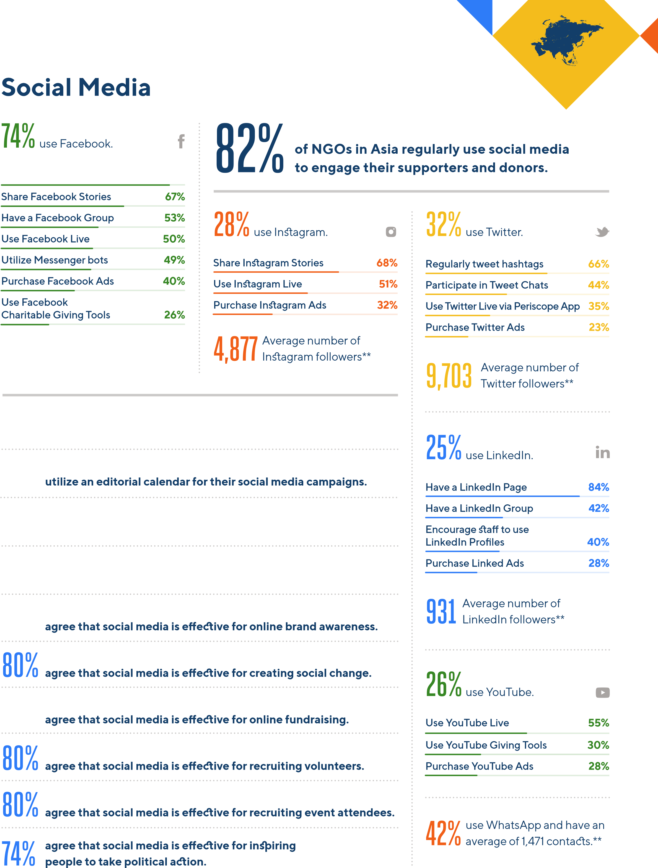**33,824** Average number of Facebook followers**

**46% of NGOs in Asia have a written social media strategy.**

## 37%

**29% have a system in place to track and report return on investment (ROI) on social media campaigns.**

**81% say that their board helps, rather than hinders, their use of social media.**

**91%**

## 76%

**Productivity & Emerging Technology**

**56**

**%**

of NGOs in Asia increased

spending on technology in 2019.

**%**

**10**

decreased spending.

**%**

**34**

made no change in their

technology budget from 2018.

**HOW WELL NGOs**

**UNDERSTAND**

**VERY**

**WELL**

**SOMEWHAT**

**WELL**

**NOT VERY**

**WELL**

**NOT**

**AT ALL**

**Artificial intelligence**

**%**

**31**

**%**

**36**

**21**

**%**

**%**

**12**

**Augmented reality**

**%**

**19**

**29**

**%**

**30**

**%**

**22**

**%**

**Blockchain technology**

**16**

**%**

**23**

**%**

**33**

**%**

**28**

**%**

**Cloud computing**

**%**

**26**

**31**

**%**

**%**

**24**

**%**

**19**

**Internet of Things**

**%**

**33**

**%**

**32**

**%**

**21**

**%**

**14**

**Machine learning**

**25**

**%**

**30**

**%**

**26**

**%**

**%**

**19**

**Predictive analytics**

**20**

**%**

**28**

**%**

**29**

**%**

**23**

**%**

**Virtual reality**

**28**

**%**

**33**

**%**

**%**

**21**

**18**

**%**

# 19% 20%

use an internal communications tool, such as Slack.

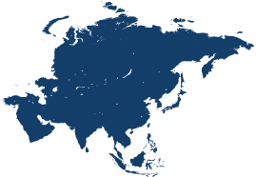use an online project management tool, such as Asana.

# 32%

purchase Google Ads;

54% have a Google Ad Grant.

## Technology Effectiveness Ratings

The top 10 most effective communication and fundraising tools, according to NGOs in Asia:

**Website 87%**

|  |  |
| --- | --- |
| **Social media** | **85%** |
| **Case studies** | **83%** |
| **Email updates** | **83%** |
| **Video** | **81%** |
| **Annual reports** | **79%** |
| **Photo slideshows/essays** | **78%** |
| **Crowdfunding** | **75%** |
| **Email fundraising appeals** | **75%** |
| **Social media ads** | **74%** |

**N P O T E C H N O L O G Y I N**

## AUSTRALIA & NEW ZEALAND

**About the Survey Respondents**

**Australia71% Top 10 CausesHuman & social services 18%**

|  |  |
| --- | --- |
| **Health & wellness** | **17%** |
| **Children & youth** | **14%** |
| **Community development** | **11%** |
| **Education** | **7%** |
| **Hunger & homelessness** | **4%** |
| **Arts & culture** | **3%** |
| **International development & relief** | **3%** |
| **Research & public policy** | **3%** |
| **Women & girls** | **3%** |

### 29%

**New Zealand**

#### Top 5 Key Findings

**Compared to the global average, NPOs in Australia & New Zealand have an exceptionally high adoption of recurring/ monthly giving at 84%, tribute giving at 49%, and peer-to-peer fundraising at 37%.**

**1**

**95% have a website. Of those, 25% are accessible to people with disabilities, the highest rate worldwide. The global average is 18%.**

**2**

**3**

**4**

**5**

**NPOs in Australia & New Zealand have the lowest participation rate in #GivingTuesday worldwide at 7%. Of those, only 20% plan to participate in 2019 despite raising 50% more in 2018 than in 2017.**

**The use of messaging apps dropped from 8% in 2018 to 3% in 2019. This decline reflects a drop in the effectiveness rating for messaging apps by NPOs worldwide from 88% in 2018 to 66% in 2019.**

**414**

**NPOs**

**Australia & New Zealand is the only region where print newsletters and print fundraising appeals make the top 10 list of the most effective communication and fundraising tools used by NPOs.**

*There is not an international standard of what defines an NGO as small, medium, or large, so survey respondents were asked to self-identify their NGO as small, medium, or large.

##### Type of Organization

**Non-profit organization (NPO) 55%**

|  |  |
| --- | --- |
| **Charity** | **21%** |
| **Non-governmental organization (NGO)** | **14%** |
| **Membership organization** | **4%** |
| **Civil society organization (CSO)** | **2%** |
| **Religious organization** | **2%** |
| **Grantmaking foundation** | **1%** |
| **Institution of higher education** | **1%** |

**Size of Organization\***

#### 14% 47%

**Large**

**Small**

#### 39%

##### Medium

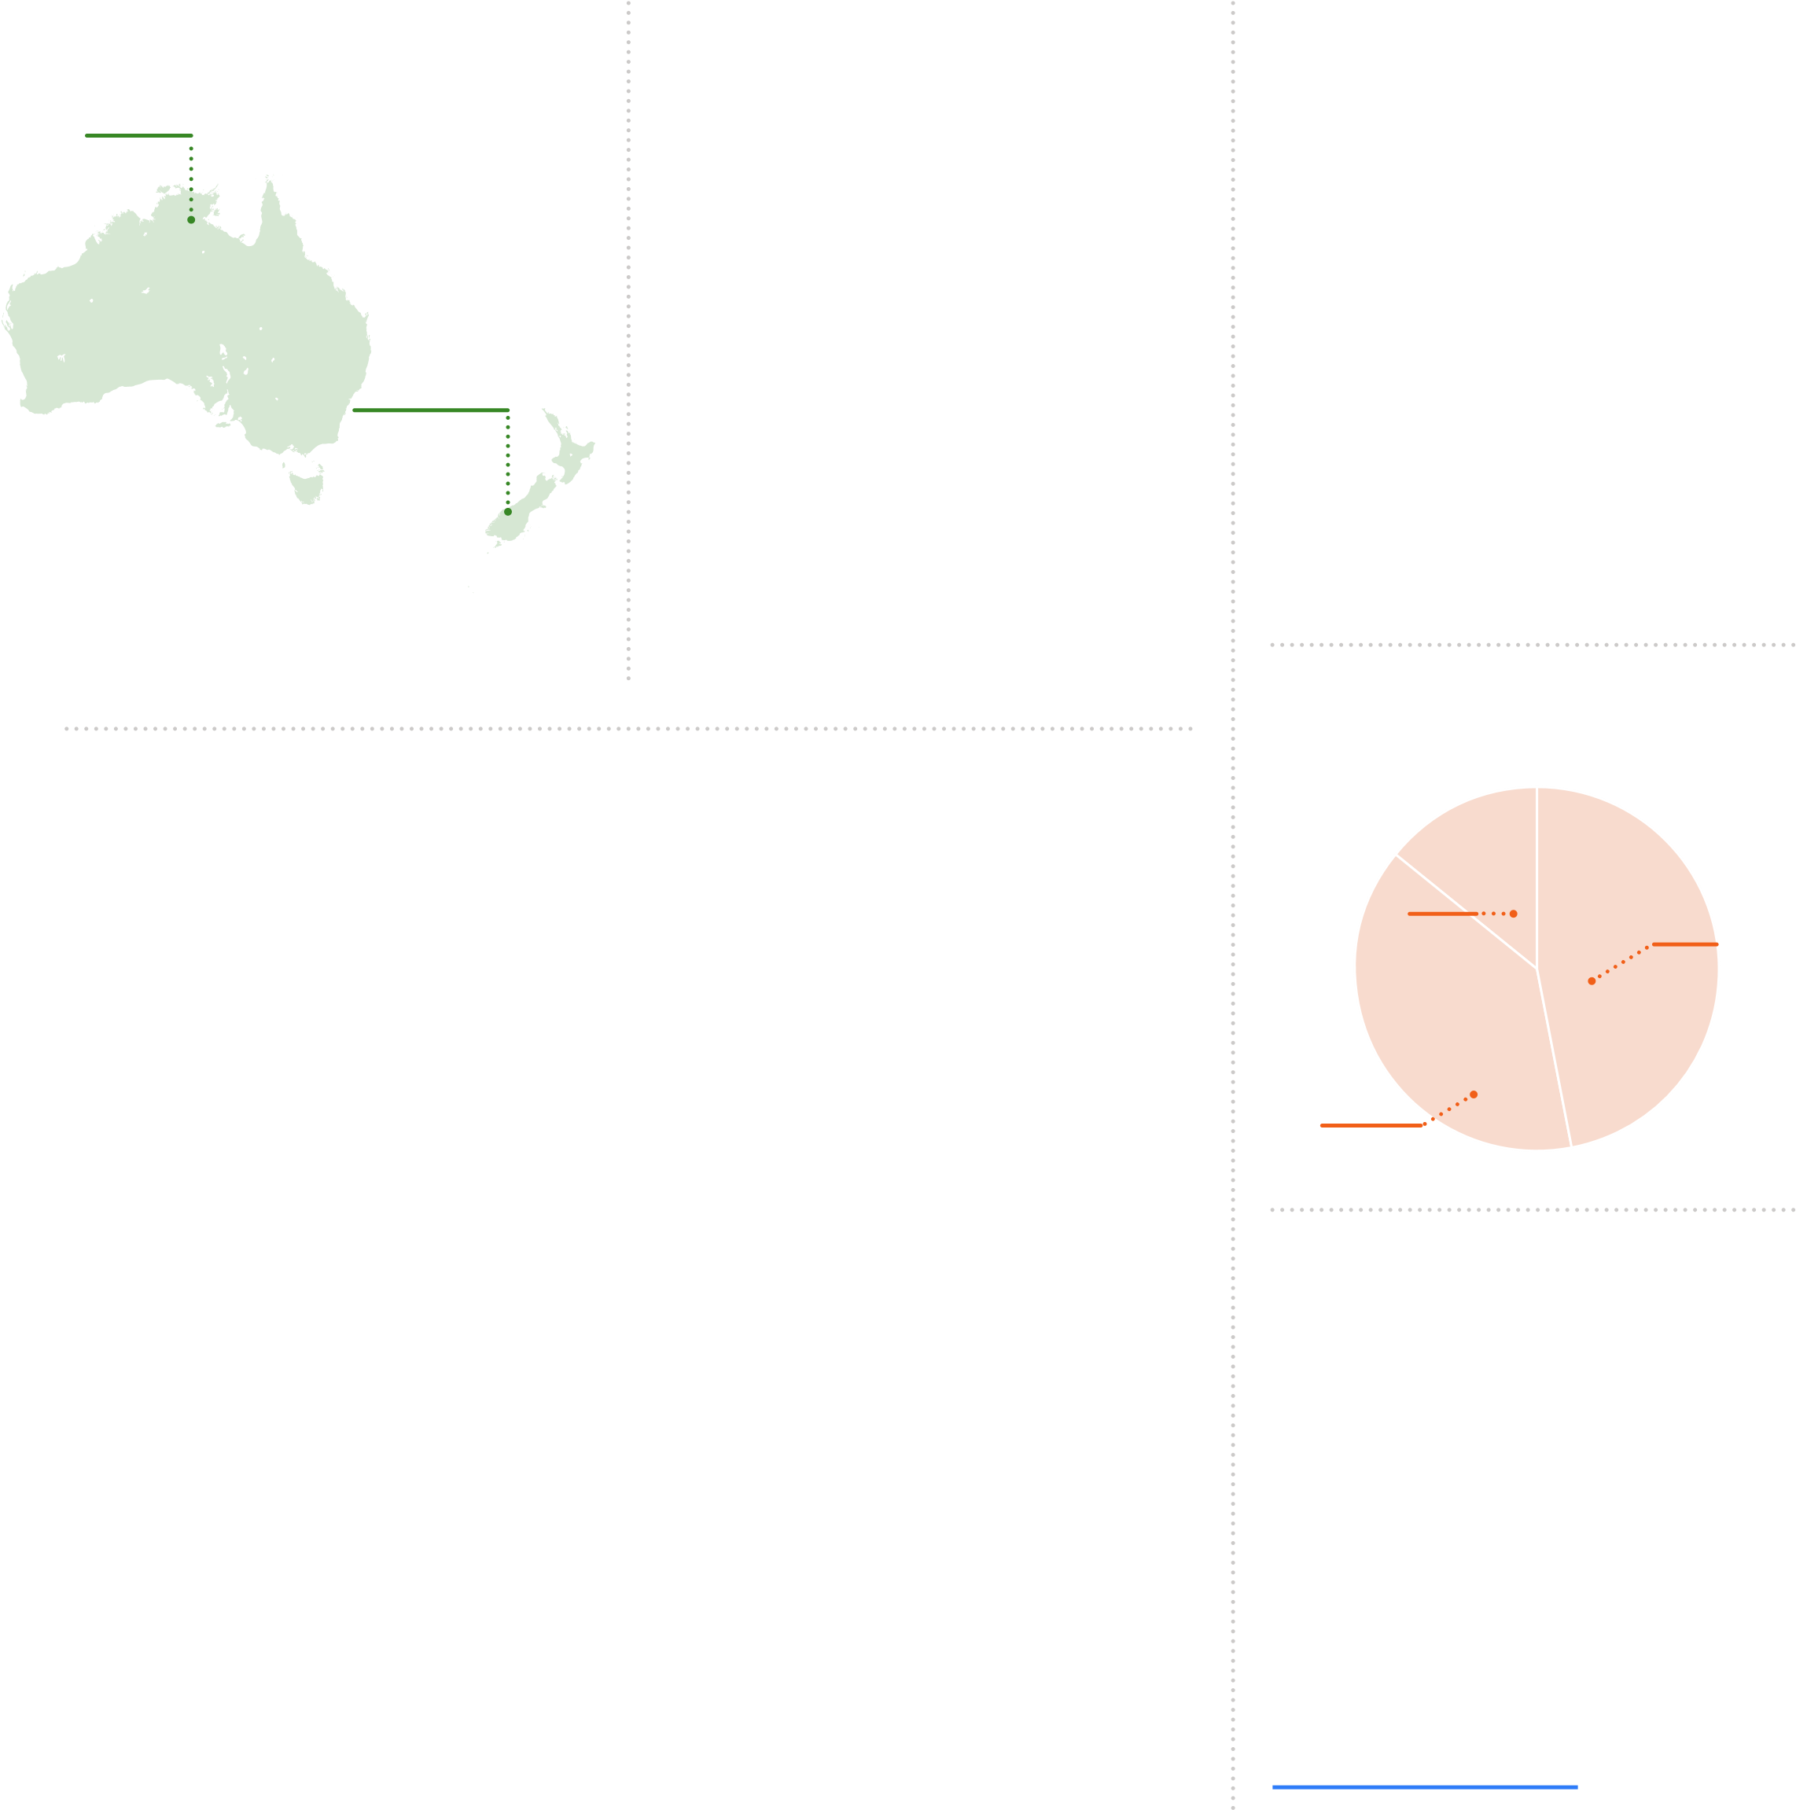**“Nearly all Australian NPOs identify social media as a key tool for communication and fundraising, yet less than half have a written strategy. This reinforces the need to upskill NPOs in order to harness the full potential of social media platforms.”**

**KAREN MAHLAB AM, CEO & FOUNDER** [**PRO BONO AUSTRALIA**](https://probonoaustralia.com.au/)

|  |
| --- |
| **Web & Email Communications** |

# 95%

of NPOs in Australia & New Zealand have a website.

## WEBSITE FEATURES

**Mobile compatibility 84%**

|  |  |
| --- | --- |
| **Privacy policy** | **78%** |
| **SSL certificate** | **76%** |
| **Event registration** | **44%** |
| **Blog** | **36%** |
| **Online store** | **21%** |
| **Accessible to people with disabilities** | **25%** |
| **Live chat** | **8%** |

** 2018 Global NGO Technology Report

## Fundraising 62%

accept online donations on their website.

send email updates also send email

**77%** to their supporters. **43%** fundraising appeals.

**1% Daily Quarterly 65%**

**2% Twice weekly Quarterly 44% Monthly 23%**

**9% Weekly Twice Monthly 6%**

**Twice monthly 10%**

Average number of

**34% Monthly 13,625** email subscribers** **use a Customer Relationship Management 47% (CRM) software to track donations and manage communications with supporters and donors.**

**38% use encryption technology to protect their data and communications.\*\***

### TYPES OF PAYMENTS FUNDRAISING TOOLS USED

**Credit card 90% Recurring/monthly giving 84%**

**Direct debit 53% Tribute giving 49%**

**Paypal 37% Peer-to-peer fundraising 37%**

**Digital wallet 3% Crowdfunding 23%**

**Cryptocurrency 2% Mobile card reader 13%**

**Text-to-give 8%**

**Giving through gaming 4%**

## #GivingTuesday

**7%** of NPOs in Australia & New Zealand participated in #GivingTuesday 2018. Of those, 74% participated for the first time.

**50%** raised more on #GivingTuesday 2018 than they did on #GivingTuesday 2017.

**20%** of those that participated in #GivingTuesday 2018 plan to participate in #GivingTuesday 2019.

**Mobile money 3%**

**Smart speaker giving 2%**

**SHARE & FOLLOW**

Are you an expert on how NPOs in Australia & New Zealand use technology? Please share articles and blog posts with your analysis of the data for Australia & New Zealand using [**#NGOtech19**](https://twitter.com/hashtag/ngotech19) on social media.

[**Download Australia &**](https://go.funraise.io/tech-report-19-AUNZ-download)

[**New Zealand Data Separately**](https://go.funraise.io/tech-report-19-AUNZ-download)

**14**

**Have a Facebook Page 99%**

### 14,079 Average number of Facebook followers**

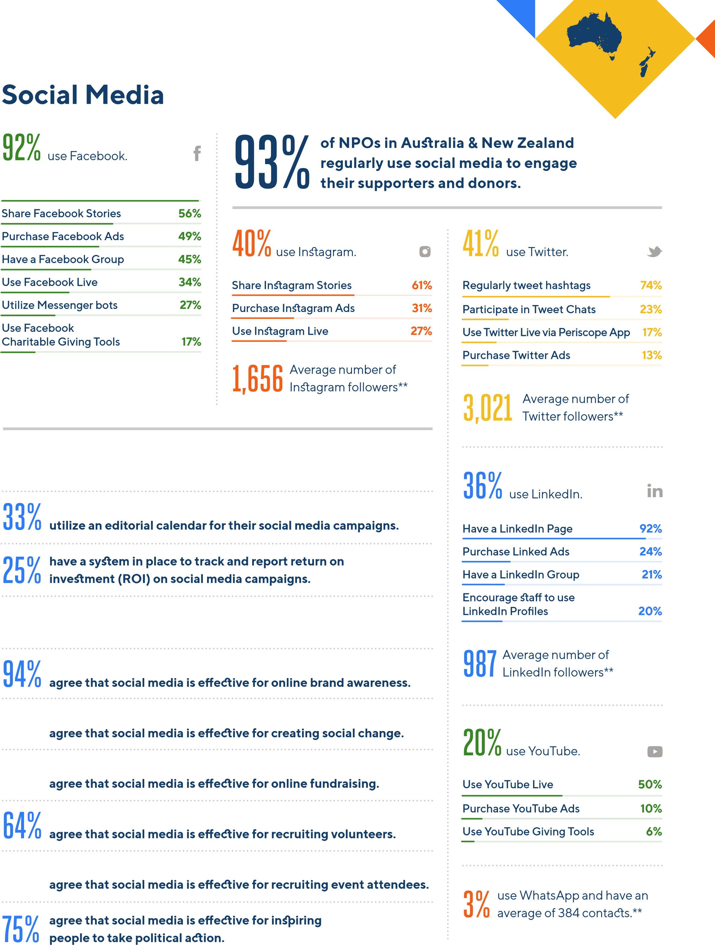**49% of NPOs in Australia & New Zealand have a written social media strategy.**

**76% say that their board helps, rather than hinders, their use of social media.**

**76% 61%**

## 76%



**Productivity & Emerging Technology**

**56**

**%**

of NPOs in Australia & New

Zealand increased spending

on technology in 2019.

**%**

**7**

decreased spending.

**%**

**37**

made no change in their

technology budget from 2018.

**HOW WELL NGOs**

**UNDERSTAND**

**VERY**

**WELL**

**SOMEWHAT**

**WELL**

**NOT VERY**

**WELL**

**NOT**

**AT ALL**

**Artificial intelligence**

**28**

**%**

**%**

**49**

**18**

**%**

**%**

**5**

**Augmented reality**

**%**

**20**

**33**

**%**

**29**

**%**

**18**

**%**

**Blockchain technology**

**8**

**%**

**23**

**%**

**38**

**%**

**31**

**%**

**Cloud computing**

**%**

**44**

**35**

**%**

**%**

**15**

**%**

**6**

**Internet of Things**

**%**

**21**

**%**

**29**

**%**

**28**

**%**

**22**

**Machine learning**

**16**

**%**

**26**

**%**

**33**

**%**

**%**

**25**

**Predictive analytics**

**15**

**%**

**34**

**%**

**35**

**%**

**16**

**%**

**Virtual reality**

**30**

**%**

**42**

**%**

**%**

**21**

**7**

**%**

# 21% 22%

use an internal communications tool, such as Slack.

use an online project management tool, such as Asana.

# 30%

purchase Google Ads;

72% have a Google Ad Grant.

## Technology Effectiveness Ratings

The top 10 most effective communication and fundraising tools, according to NPOs in Australia & New Zealand:

**Website 83%**

|  |  |
| --- | --- |
| **Email updates** | **82%** |
| **Social media** | **78%** |
| **Case studies** | **77%** |
| **Video** | **74%** |
| **Infographics** | **68%** |
| **Email fundraising appeals** | **61%** |
| **Social media ads** | **61%** |
| **Print newsletters** | **58%** |
| **Print fundraising appeals** | **57%** |

**N P O T E C H N O L O G Y I N**

## EUROPE

### About the Survey Respondents

#### Top 5 Countries Top 10 Causes

|  |  |
| --- | --- |
| **Health & wellness** | **13%** |
| **Human & social services** | **10%** |
| **Community development** | **9%** |
| **Education** | **9%** |
| **Human & civil rights** | **7%** |
| **International development & relief** | **6%** |
| **Disability rights** | **5%** |
| **Environment** | **5%** |
| **Research & public policy** | **4%** |

**18% 12% Children & youth 13%**

#### Type of Organization

**Non-profit organization (NPO) 37%**

**Ireland England**

**~~8~~%**

**France**

### 17~~%~~ 20%

**Spain Greece**

#### Top 5 Key Findings

**95% of NPOs in Europe have a website, yet only 56% accept online donations on their website—8% below the global average. Interestingly, 26% have an online store, the highest rate worldwide.**

**1**

**2**

**3**

**4**

**5**

**86% have a privacy policy on their website, more than any other region. 40% use encryption technology to protect their data. These high rates of data protection likely reflect the impact of GDPR.**

**European NPOs are embracing email marketing. 80% send email updates to supporters and donors, up from 57% in 2018. Of those, 39% send email updates monthly, 29% quarterly, and 13% weekly.**

**754**

**NPOs**

**34**

**Countries**

**23% utilize text-to-give, more than any other region. Of those that use text-to-give, 55% find the technology effective for fundraising —9% higher than NPOs in other regions that use text-to-give.**

**42% of NPOs in Europe purchase Google Ads, the highest rate worldwide. They also exceed the global average for investing in advertising on Facebook at 54%, Instagram 38%, and Twitter 18%.**

*There is not an international standard of what defines an NGO as small, medium, or large, so survey respondents were asked to self-identify their NGO as small, medium, or large.

|  |  |
| --- | --- |
| **Non-governmental organization (NGO)** | **26%** |
| **Charity** | **20%** |
| **Civil society organization (CSO)** | **7%** |
| **Membership organization** | **5%** |
| **Grantmaking foundation** | **2%** |
| **Religious organization** | **2%** |
| **Institution of higher education** | **1%** |

**Size of Organization\***

### 13% 49%

**Large**

**Small**

#### 38%

##### Medium

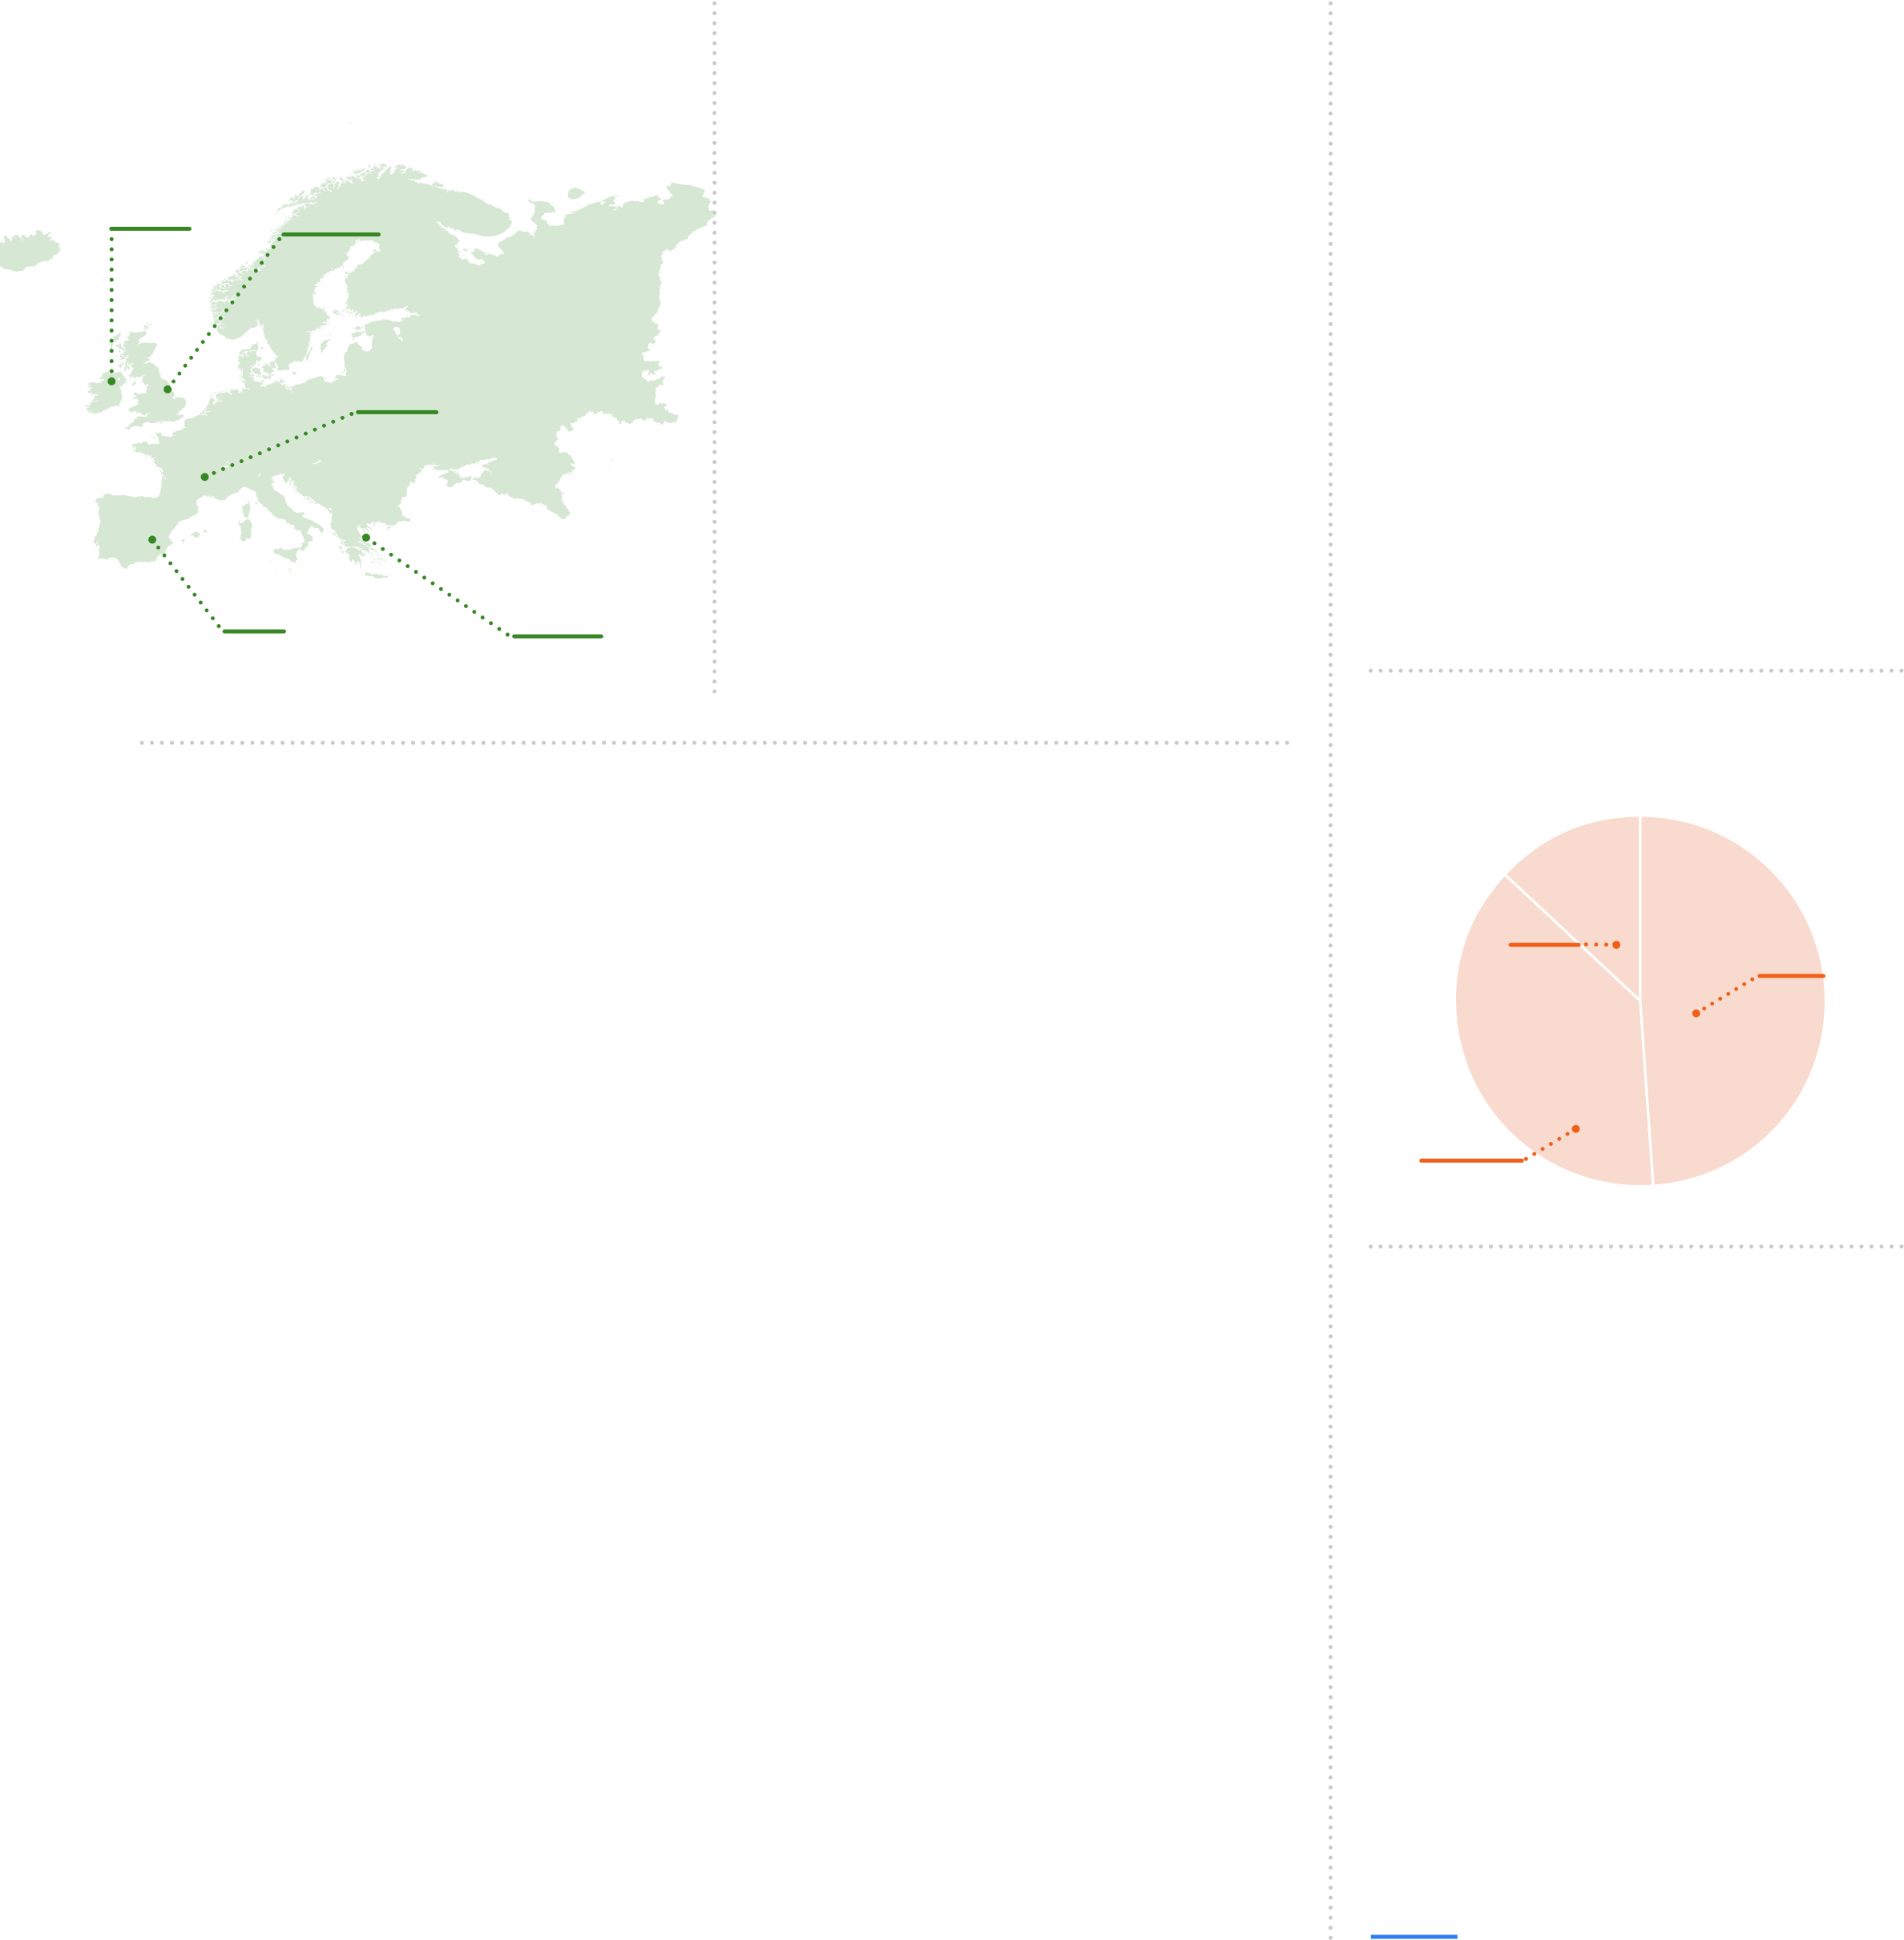**“A decade ago, NPOs in Europe that had a mobile website and a Facebook Page were at the forefront of technology. Today, those tools are standard practice. Early-adopter NPOs are now shifting their focus to mastering the tools of the AI Revolution—chatbots, voice commands, and machine learning.”**

**ARIS SOURAS, MANAGER**

[**HIGGS**](https://higgs3.org/en/) **(GREECE)**

|  |
| --- |
| **Web & Email Communications** |

# 95%

of NPOs in Europe have a website.

## WEBSITE FEATURES

**Mobile compatibility 87%**

|  |  |
| --- | --- |
| **Privacy policy** | **86%** |
| **SSL certificate** | **76%** |
| **Event registration** | **52%** |
| **Blog** | **51%** |
| **Online store** | **26%** |
| **Accessible to people with disabilities** | **22%** |
| **Live chat** | **7%** |

** 2018 Global NGO Technology Report

## Fundraising 56%

accept online donations on their website.

send email updates also send email

**80%** to their supporters. **49%** fundraising appeals.

**3% Twice weekly Quarterly 54%**

**4% Daily Monthly 27%**

**12% Twice monthly Monthly 39% Twice Monthly 8%**

**13% Weekly**

Average number of

**Quarterly 29% 23,181** email subscribers**

**use a Customer Relationship Management 43% (CRM) software to track donations and manage communications with supporters and donors.**

**40% use encryption technology to protect their data and communications.\*\***

### TYPES OF PAYMENTS FUNDRAISING TOOLS USED

**Credit card 84% Recurring/monthly giving 77%**

**Paypal 57% Tribute giving 40%**

**Direct debit 54% Crowdfunding 37%**

**Digital wallet 6% Peer-to-peer fundraising 34%**

**Cryptocurrency 2% Text-to-give 23%**

**Mobile card reader 8%**

**Mobile money 4%**

## #GivingTuesday

**25%** of NPOs in Europe participated in #GivingTuesday 2018. Of those, 49% participated for the first time.

**41%** raised more on #GivingTuesday 2018 than they did on #GivingTuesday 2017.

**42%** of those that participated in #GivingTuesday 2018 plan to participate in #GivingTuesday 2019.

**Giving through gaming 3%**

**Smart speaker giving 2%**

**SHARE & FOLLOW**

Are you an expert on how NPOs in Europe use technology? Please share articles and blog posts with your analysis of the data for Europe using [**#NGOtech19**](https://twitter.com/hashtag/ngotech19) on social media.

[**Download Europe Data Separately**](https://go.funraise.io/tech-report-19-europe-download)

**18**

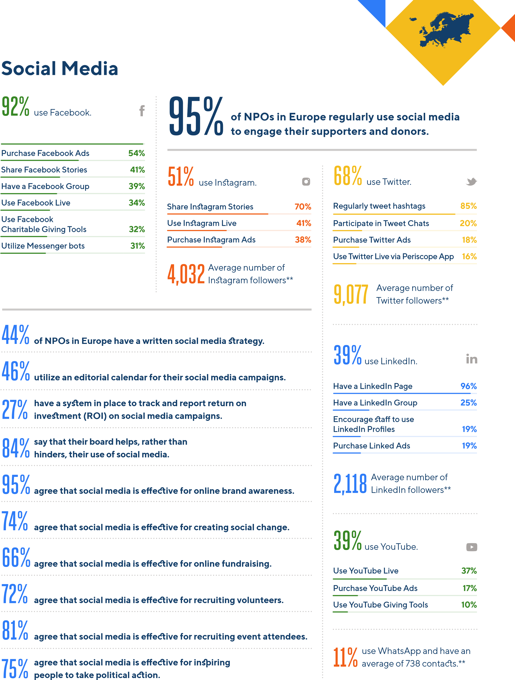 **Have a Facebook Page 99%**

Average number of

**27,204** Facebook followers**

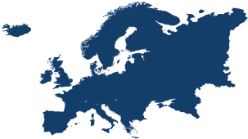

**Productivity & Emerging Technology**

**50**

**%**

of NPOs in Europe increased

spending on technology in 2019.

**%**

**8**

decreased spending.

**%**

**42**

made no change in their

technology budget from 2018.

**HOW WELL NGOs**

**UNDERSTAND**

**VERY**

**WELL**

**SOMEWHAT**

**WELL**

**NOT VERY**

**WELL**

**NOT**

**AT ALL**

**Artificial intelligence**

**%**

**36**

**%**

**43**

**17**

**%**

**%**

**4**

**Augmented reality**

**%**

**29**

**37**

**%**

**22**

**%**

**12**

**%**

**Blockchain technology**

**13**

**%**

**23**

**%**

**39**

**%**

**25**

**%**

**Cloud computing**

**%**

**44**

**34**

**%**

**%**

**15**

**%**

**7**

**Internet of Things**

**%**

**33**

**%**

**36**

**%**

**21**

**%**

**10**

**Machine learning**

**22**

**%**

**36**

**%**

**28**

**%**

**%**

**14**

**Predictive analytics**

**18**

**%**

**34**

**%**

**33**

**%**

**15**

**%**

**Virtual reality**

**42**

**%**

**38**

**%**

**%**

**15**

**5**

**%**

# 22% 23%

use an internal communications tool, such as Slack.

use an online project management tool, such as Asana.

# 42%

purchase Google Ads;

73% have a Google Ad Grant.

## Technology Effectiveness Ratings

The top 10 most effective communication and fundraising tools, according to NPOs in Europe:

**Website 87%**

|  |  |
| --- | --- |
| **Social media** | **85%** |
| **Email updates** | **79%** |
| **Case studies** | **74%** |
| **Infographics** | **74%** |
| **Social media ads** | **69%** |
| **Email fundraising appeals** | **64%** |
| **Photo slideshows/essays** | **63%** |
| **Peer-to-peer fundraising** | **61%** |
| **Search engine ads** | **57%** |

**N P O T E C H N O L O G Y I N**

## LATIN AMERICA & THE CARIBBEAN

### About the Survey Respondents

#### Top 5 Countries Top 10 Causes 32% 17% Children & youth 19%

**Community development 16%**

**Mexico Dominican**

**Republic Education 10%**

**Health & wellness 9%**

**22% Human & social services 8%**

**3**

**% Brazil**

**Environment 6%**

**Venezuela**

**Human & civil rights 6%**

**Women & girls 5%**

**Disability rights 4%**

**5**

**%**

**Argentina Arts & culture 3%**

### Top 5 Key Findings

**NPOs in Latin America & the Caribbean lag behind other NPOs worldwide in their adoption of emerging fundraising tools. Only 3% utilize digital wallets, 1% cryptocurrency, and 1% smart speaker giving.**

**1**

**47% use WhatsApp to communicate with supporters and donors, the highest rate worldwide. Of those, 72% find WhatsApp effective, 16% higher than the global average.**

**2**

**3**

**4**

**5**

#### Type of Organization

**820**

**NPOs**

**29**

**Countries**

**Non-profit organization (NPO) 34%**

|  |  |
| --- | --- |
| **Civil society organization (CSO)** | **33%** |
| **Non-governmental organization (NGO)** | **18%** |
| **Membership organization** | **6%** |
| **Charity** | **4%** |
| **Grantmaking foundation** | **2%** |
| **Religious organization** | **2%** |
| **Institution of higher education** | **1%** |

**Size of Organization\***

### 12% Large 51% 37%

**Small**

#### Medium

**“The mobile revolution occurring**

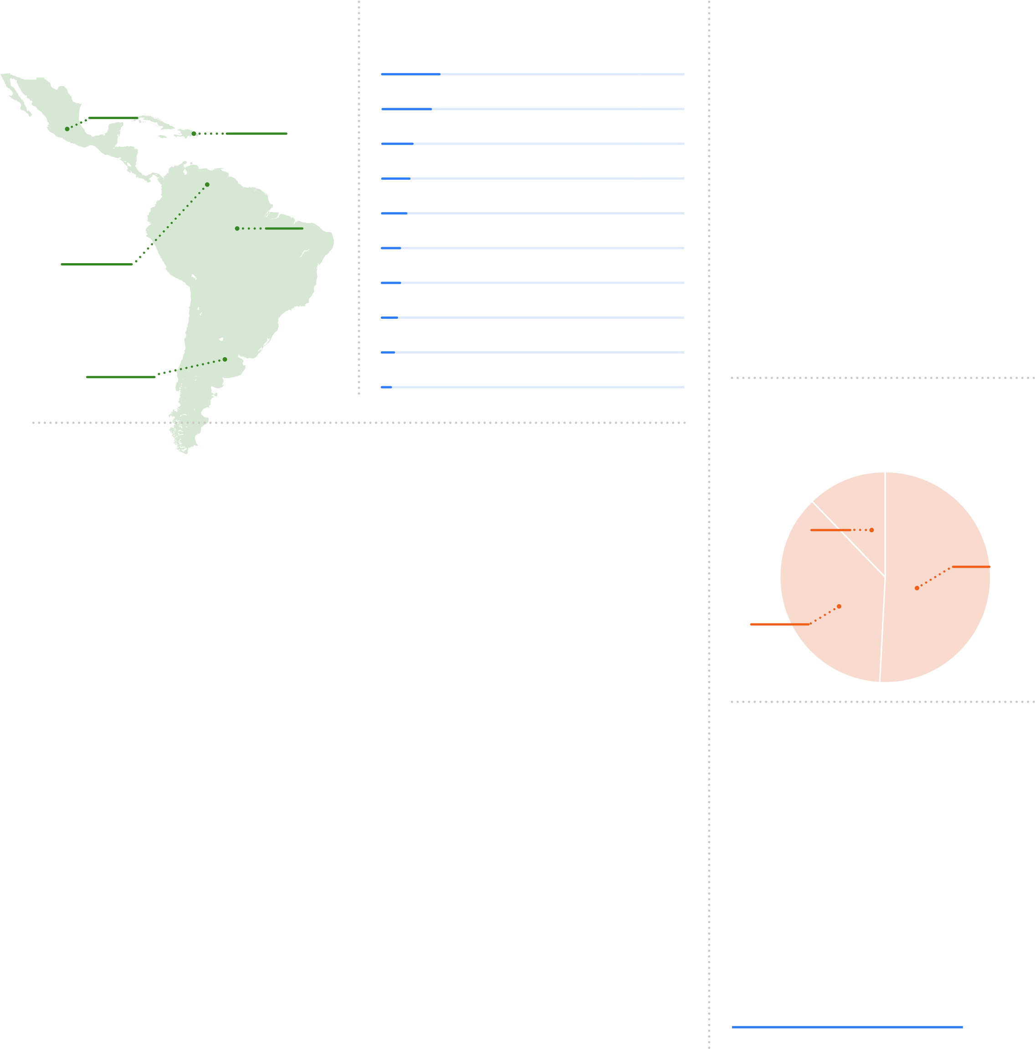**NPOs are advanced in their use of Instagram with 53% regularly throughout Latin America & using Instagram to engage their supporters and donors. Of those, the Caribbean has empowered 73% publish Stories, the highest rate worldwide, and 45% go live. NPOs to inspire a new generation of activists and donors that will Latin American & Caribbean NPOs embrace online advocacy. 81% transform the business sector agree that social media is effective for inspiring political action and and government institutions for 68% find online petitions effective, the highest rates worldwide. generations to come.”**

**58% send email updates to supporters and donors, up from 45% HEATHER MANSFIELD, in 2018. Of those, 41% send email updates monthly, 33% FOUNDER & EDITOR-IN-CHIEF**

[**NONPROFIT TECH FOR GOOD**](https://www.nptechforgood.com/) **quarterly, and 9% weekly.**

*There is not an international standard of what defines an NGO as small, medium, or large, so survey respondents were asked to self-identify their NGO as small, medium, or large.

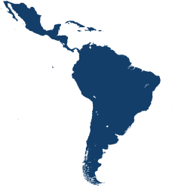

**Web & Email Communications**

# 81%

of NPOs in Latin America & the Caribbean have a website.

## WEBSITE FEATURES

**Mobile compatibility 88%**

|  |  |
| --- | --- |
| **SSL certificate** | **61%** |
| **Privacy policy** | **60%** |
| **Event registration** | **48%** |
| **Blog** | **38%** |
| **Online store** | **14%** |
| **Live chat** | **10%** |
| **Accessible to people with disabilities** | **7%** |

** 2018 Global NGO Technology Report

## Fundraising 56%

accept online donations on their website.

send email updates also send email

**58%** to their supporters. **39%** fundraising appeals.

**3% Twice weekly Quarterly 45%**

**5% Daily Monthly 41% Monthly 32%**

**9% Weekly Twice Monthly 9%**

**Twice monthly 9%**

**33% Quarterly** Average number of

**9,725** email subscribers**

**use a Customer Relationship Management 22% (CRM) software to track donations and manage communications with supporters and donors.**

**31% use encryption technology to protect their data and communications.\*\***

### TYPES OF PAYMENTS FUNDRAISING TOOLS USED

**Credit card 67% Recurring/monthly giving 81%**

**Paypal 61% Crowdfunding 27%**

**Direct debit 41% Peer-to-peer fundraising 20%**

**Digital wallet 3% Tribute giving 20%**

**Cryptocurrency 1% Mobile card reader 6%**

**Mobile money 3%**

**Text-to-give 1%**

## #GivingTuesday

**20%** of NPOs in Latin America and the Caribbean participated in #GivingTuesday 2018. Of those, 36% participated for the first time.

**50%** raised more on #GivingTuesday 2018 than they did on #GivingTuesday 2017.

**73%** of those that participated in #GivingTuesday 2018 plan to participate in #GivingTuesday 2019.

**Smart speaker giving 1%**

**Giving through gaming 0%**

**SHARE & FOLLOW**

Are you an expert on how NPOs in Latin America and the Caribbean use technology? Please share articles and blog posts with your analysis of the data for Latin America and the Caribbean using [**#NGOtech19**](https://twitter.com/hashtag/ngotech19) on social media.

[**Download Latin America & the Caribbean Data Separately**](https://go.funraise.io/tech-report-19-LACARIB-download)

**22**

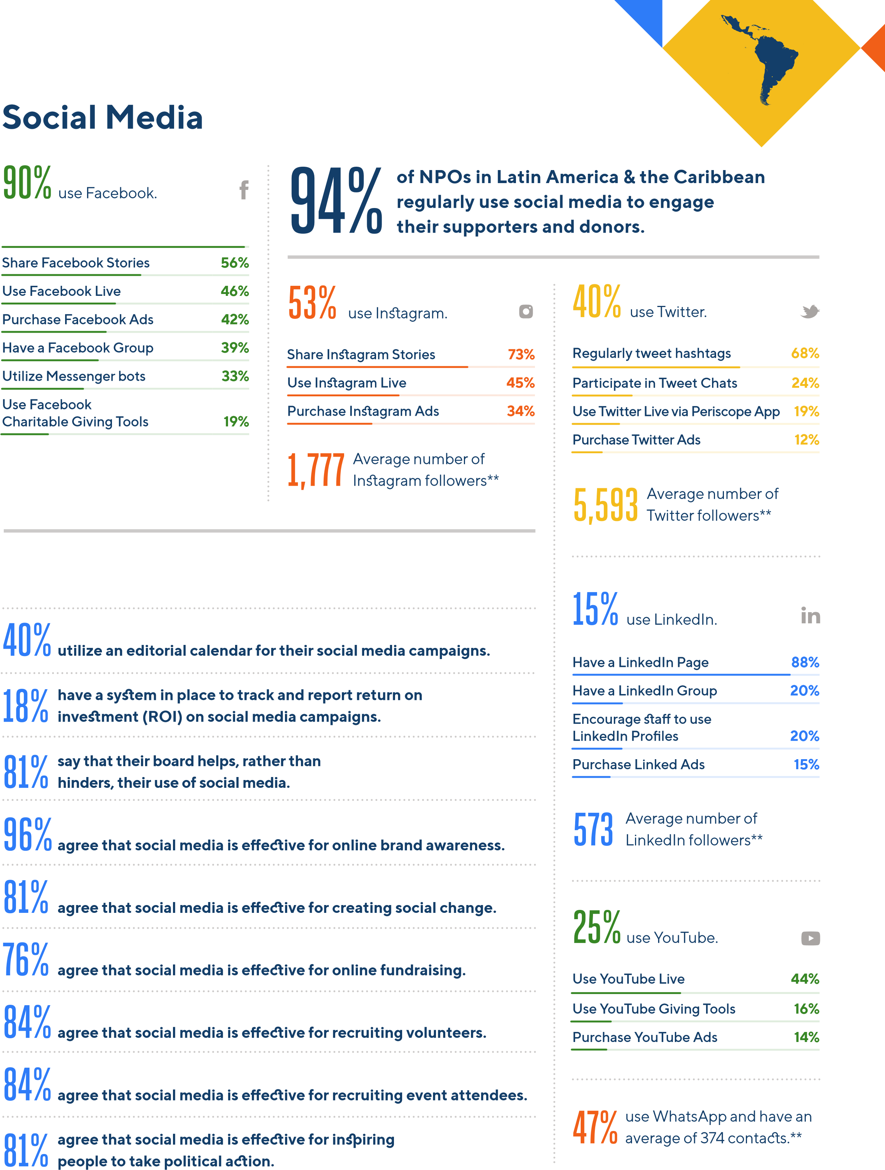 **Have a Facebook Page 98%**

Average number of

**13,360** Facebook followers** **of NPOs in Latin America & the Caribbean 41% have a written social media strategy.**



## Productivity & Emerging Technology

**40**

**%**

of NPOs in Latin America & the

Caribbean increased spending

on technology in 2019.

**%**

**14**

decreased spending.

**%**

**46**

made no change in their

technology budget from 2018.

**HOW WELL NGOs**

**UNDERSTAND**

**VERY**

**WELL**

**SOMEWHAT**

**WELL**

**NOT VERY**

**WELL**

**NOT**

**AT ALL**

**Artificial intelligence**

**36**

**%**

**%**

**42**

**16**

**%**

**%**

**6**

**Augmented reality**

**%**

**31**

**33**

**%**

**24**

**%**

**12**

**%**

**Blockchain technology**

**11**

**%**

**18**

**%**

**37**

**%**

**34**

**%**

**Cloud computing**

**%**

**47**

**30**

**%**

**%**

**16**

**%**

**7**

**Internet of Things**

**%**

**33**

**%**

**31**

**%**

**22**

**%**

**14**

**Machine learning**

**26**

**%**

**32**

**%**

**27**

**%**

**%**

**15**

**Predictive analytics**

**20**

**%**

**30**

**%**

**30**

**%**

**20**

**%**

**Virtual reality**

**39**

**%**

**36**

**%**

**%**

**18**

**7**

**%**

# 10% 13%

use an internal communications tool, such as Slack.

use an online project management tool, such as Asana.

# 24%

purchase Google Ads;

60% have a Google Ad Grant.

## Technology Effectiveness Ratings

The top 10 most effective communication and fundraising tools, according to NPOs in Latin America & the Caribbean:

**Social media 87%**

|  |  |
| --- | --- |
| **Video** | **86%** |
| **Website** | **85%** |
| **Social media ads** | **80%** |
| **Email updates** | **79%** |
| **Infographics** | **79%** |
| **Case studies** | **77%** |
| **Photo slideshows/essays** | **75%** |
| **Crowdfunding** | **72%** |
| **Online Petitions** | **68%** |

**N P O T E C H N O L O G Y I N**

## UNITED STATES & CANADA

### About the Survey Respondents

**Top 10 Causes**

**Children & youth 13%**

#### Type of Organization

**Non-profit organization (NPO) 72%**

|  |  |
| --- | --- |
| **Human & social services** | **13%** |
| **Education** | **12%** |
| **Health & wellness** | **11%** |
| **Community development** | **9%** |
| **Arts & culture** | **6%** |
| **Faith & spirituality** | **5%** |
| **Environment & conservation** | **4%** |
| **Women & girls** | **4%** |
| **Human & civil rights** | **3%** |

### 14% 86%

**Canada**

**United States**

#### Top 5 Key Findings

**97% of NPOs in the United States & Canada have a website. Of those, 85% accept online donations on their website, the highest rate worldwide. However, only 6% offer live chat, the lowest rate worldwide.**

**1**

**39% use a peer-to-peer fundraising tool, up from 31% in 2018 and the highest rate worldwide. The adoption of crowdfunding, however, remains low at 24%—7% below the global average.**

**1,071**

**NPOs**

**2**

**3**

**4**

**5**

**The use of mobile card readers is high at 34%, but the adoption of other emerging fundraising tools, such as cryptocurrency, giving through gaming, and smart speaker giving is below the global average.**

**58% participate in #GivingTuesday, the highest rate worldwide. Of those, 62% raised more money on #GivingTuesday 2018 than they did in 2017. 70% plan to participate in #GivingTuesday 2019.**

**The understanding of emerging technology by NPO staff is higher than the global average. 79% say they understand Artificial Intelligence, 75% cloud computing, and 58% predictive analytics.**

*There is not an international standard of what defines an NGO as small, medium, or large, so survey respondents were asked to self-identify their NGO as small, medium, or large.

|  |  |
| --- | --- |
| **Charity** | **8%** |
| **Non-governmental organization (NGO)** | **6%** |
| **Religious organization** | **6%** |
| **Membership organization** | **3%** |
| **Grantmaking foundation** | **2%** |
| **Institution of higher education** | **2%** |
| **Civil Society Organization (CSO)** | **1%** |

##### Size of Organization*

**59**

**%**

**Small**

**8**

**%**

**Large**

**33**

**%**

**Medium**

**“As the 1.6 million US and Canadian NPOs fully embrace online funding streams— crowdfunding, peer-to-peer, textto-give—the impact of nonprofit organizations worldwide will increase exponentially. It's our responsibility to ensure all NPOs are included in this wave of future funding."**

**JUSTIN WHEELER, CEO & CO-FOUNDER**

[**FUNRAISE**](http://funraise.org/)

|  |
| --- |
| **Web & Email Communications** |

# 97%

of NPOs in the United States & Canada have a website.

## WEBSITE FEATURES

**Mobile compatibility 92%**

|  |  |
| --- | --- |
| **SSL certificate** | **81%** |
| **Event registration** | **67%** |
| **Privacy policy** | **66%** |
| **Blog** | **52%** |
| **Accessible to people with disabilities** | **21%** |
| **Online store** | **21%** |
| **Live chat** | **6%** |

** 2018 Global NGO Technology Report

## Fundraising 85%

accept online donations on their website.

send email updates also send email

**82%** to their supporters. **66%** fundraising appeals.

**2% Daily Quarterly 67%**

**2% Twice weekly Monthly 46% Monthly 20%**

**11% Weekly Twice Monthly 7%**

**Twice monthly 13%**

**26% Quarterly** Average number of

**21,839** email subscribers**

**use a Customer Relationship Management 64% (CRM) software to track donations and manage communications with supporters and donors.**

**46% use encryption technology to protect their data and communications.\*\***

### TYPES OF PAYMENTS FUNDRAISING TOOLS USED

**Credit card 92% Recurring/monthly giving 84%**

**Paypal 50% Tribute giving 68%**

**Direct debit 32% Peer-to-peer fundraising 39%**

**Digital wallet 7% Mobile card reader 34%**

**Cryptocurrency 2% Crowdfunding 24%**

**Text-to-give 13%**

**Smart speaker giving 2%**

## #GivingTuesday

**58%** of NPOs in the United States & Canada participated in #GivingTuesday 2018. Of those, 15% participated for the first time.

**62%** raised more on #GivingTuesday 2018 than they did on #GivingTuesday 2017.

**70%** of those that participated in #GivingTuesday 2018 plan to participate in #GivingTuesday 2019.

**Giving through gaming 1%**

**Mobile money 1%**

**SHARE & FOLLOW**

Are you an expert on how NPOs in United States & Canada use technology? Please share articles and blog posts with your analysis of the data for United States & Canada using [**#NGOtech19**](https://twitter.com/hashtag/ngotech19) on social media.

[**Download United States &**](https://go.funraise.io/tech-report-19-USCA-download)

[**Canada Data Separately**](https://go.funraise.io/tech-report-19-USCA-download)

**26**

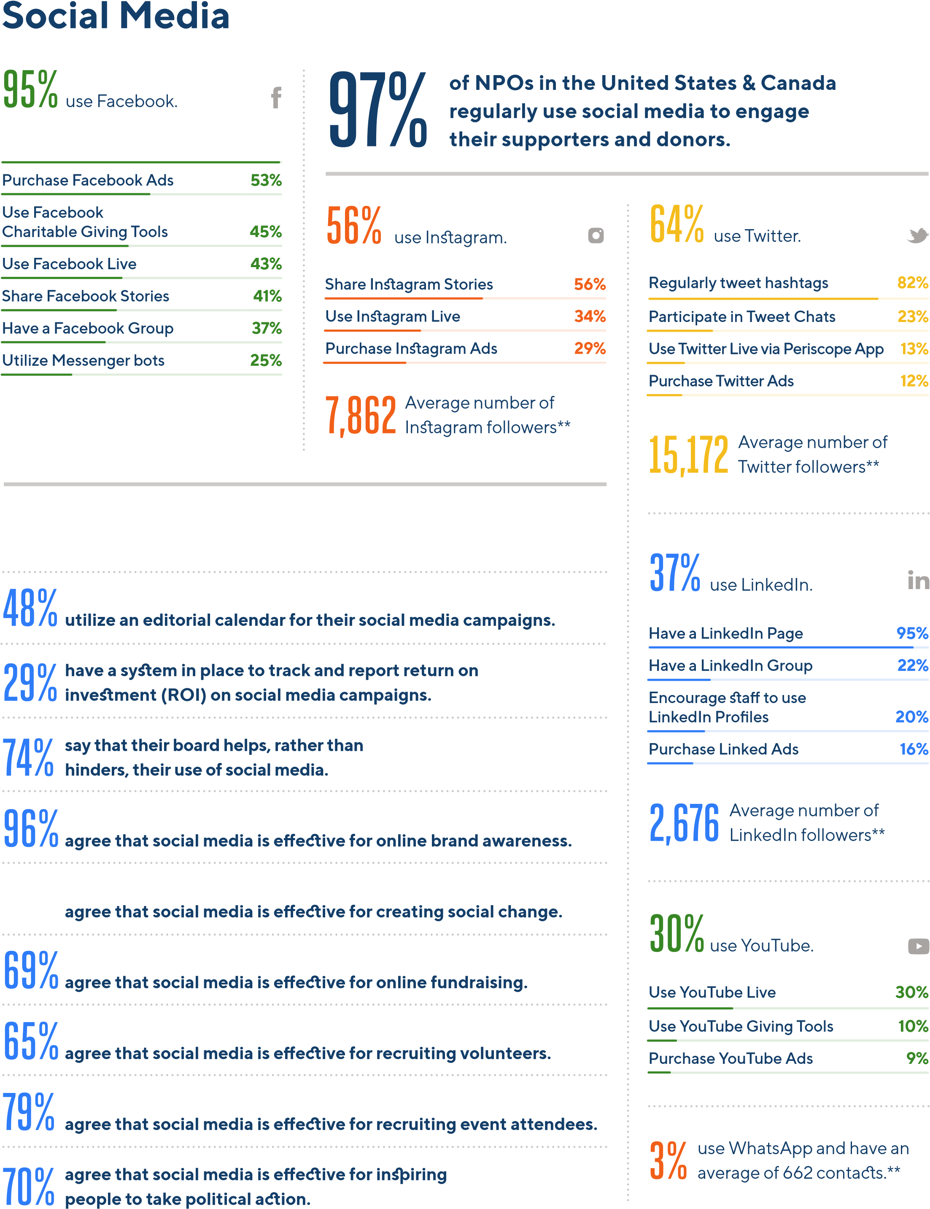 **Have a Facebook Page 99%**

**26,766** Average number of Facebook followers**

**40% of NPOs in the United States & Canada have a written social media strategy.**

## 71%

### Productivity & Emerging Technology

**48**

**%**

of NPOs in the United States

& Canada increased spending

on technology in 2019.

**%**

**8**

decreased spending.

**%**

**44**

made no change in their

technology budget from 2018.

**HOW WELL NGOs**

**UNDERSTAND**

**VERY**

**WELL**

**SOMEWHAT**

**WELL**

**NOT VERY**

**WELL**

**NOT**

**AT ALL**

**Artificial intelligence**

**30**

**%**

**%**

**49**

**18**

**%**

**%**

**3**

**Augmented reality**

**%**

**20**

**32**

**%**

**32**

**%**

**16**

**%**

**Blockchain technology**

**9**

**%**

**20**

**%**

**35**

**%**

**36**

**%**

**Cloud computing**

**%**

**38**

**37**

**%**

**%**

**17**

**%**

**8**

**Internet of Things**

**%**

**25**

**%**

**30**

**%**

**24**

**%**

**21**

**Machine learning**

**16**

**%**

**32**

**%**

**32**

**%**

**%**

**20**

**Predictive analytics**

**20**

**%**

**38**

**%**

**28**

**%**

**14**

**%**

**Virtual reality**

**36**

**%**

**41**

**%**

**%**

**18**

**5**

**%**

# 22% 29%

use an internal communications tool, such as Slack.

use an online project management tool, such as Asana.

# 33%

purchase Google Ads;

73% have a Google Ad Grant.

## Technology Effectiveness Ratings

The top 10 most effective communication and fundraising tools, according to NPOs in the United States & Canada:

**Website 87%**

|  |  |
| --- | --- |
| **Case studies** | **86%** |
| **Email updates** | **84%** |
| **Social media** | **83%** |
| **Video** | **81%** |
| **Email fundraising appeals** | **72%** |
| **Infographics** | **72%** |
| **Print fundraising appeals** | **67%** |
| **Online petitions** | **65%** |
| **Photo slideshows/essays** | **65%** |

### Fundraising

**Top 5 Causes**

**Children & youth**

**%**

**16**

**Community development**

**%**

**13**

**Education**

**12**

**%**

**Health & wellness**

**11**

**%**

**Human & social services**

**8**

**%**

* There is not an international standard of what

defines an NGO as small, medium, or large, so

survey respondents were asked to self-identify

their NGO as small, medium, or large.

** 2018 Global NGO Technology Report

**20**

**%**

**of NGOs worldwide accept online donations on their website.** **64%** Of those, **79%** accept credit card payments, **50%** direct debit, **46%** PayPal, **10%** accept digital wallet payments, and **2%** Bitcoin.

**use a Customer Relationship Management (CRM) software to**

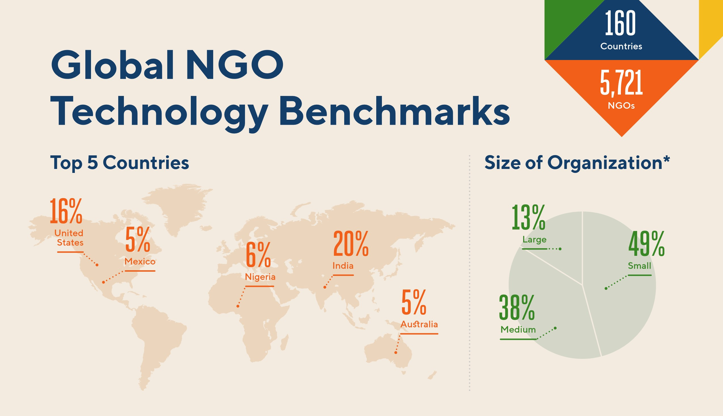**40% track donations and manage communications with supporters and donors.** Of those, 24% are unsatisfied with their current CRM software because it’s difficult to use (**29%**), legacy and lacking in modern capabilities (**28%**), incompatible with many third-party apps (**21%**), too expensive (**12%**), and not cloud-based (**10%**). **use encryption technology** to protect their data and

**41%** communications.**

**utilize recurring/monthly giving,** **34%** tribute giving, **31%**

**68%** crowdfunding, **30%** peer-to-peer fundraising, **14%** a mobile card reader, **12%** text-to-give, **9%** mobile money, **3%** smart speaker giving, and **2%** giving through gaming.

**participated in #GivingTuesday 2018.** Of those, **30%** participated **27%** for the first time. **59%** raised more on #GivingTuesday 2018 than they did on #GivingTuesday 2017. **60%** of those that participated in #GivingTuesday 2018 plan to participate in #GivingTuesday 2019.

### Web & Email Communications

**80%** **88%** are mobile compatible, **71%** have a privacy **of NGOs worldwide have a website.** Of those,

policy, **70%** have an SSL certificate, **54%** have event registration, **48%** have a blog, **23%** have an online store, **18%** are accessible to people with disabilities, and **12%** have live chat.

**71%** **and donors** and have an average of 14,021 email **regularly send email updates to supporters**

subscribers.** Of those, **35%** send monthly, **30%** quarterly, **13%** weekly, **10%** twice monthly, **8%** daily, and **4%** twice weekly. **54%** also send email fundraising appeals. Of those, **48%** send quarterly, **25%** monthly, **8%** weekly and twice monthly, **7%** daily, and **4%** twice weekly.

**Productivity &**

### Emerging Technology

**of NGOs worldwide use an internal 19% communications tool,** such as Slack. **use an online project management tool, 22%** such as Asana.

**increased spending on technology in 2019.** **51% 10%** decreased spending. **39%** made no change in their technology budget from 2018.

**purchase Google Ads;**

**33% 62%** have a Google Ad Grant. **74% 70%** virtual reality, **69%** cloud computing, **69%** **understand artificial intelligence**,

Internet of Things, **54%** augmented reality, **53%** machine learning, **51%** predictive analytics, and **34%** blockchain technology.

* There is not an international standard of what defines an NGO as small, medium, or large, so survey respondents were asked to self-identify their NGO as small, medium, or large.

** 2018 Global NGO Technology Report

### Social Media

**of NGOs worldwide regularly use social media to 90% engage their supporters and donors.** **94%** agree that social media is effective for online brand awareness, **80%** for recruiting event attendees, **78%** for creating social change, **75%** for recruiting volunteers and inspiring people to take political action, and **72%** for online fundraising.

**use Facebook** and have an average of 20,606 **84%** followers**. Of those, **97%** have a Facebook

Page, **54%** share Facebook Stories, **47%** purchase

Facebook Ads, **44%** have a Facebook Group, **43%** use Facebook Live, **36%** utilize Messenger bots, and **29%** use Facebook Charitable Giving Tools.

**use Twitter** and have an average of 8,033 **46%** followers**. Of those, **76%** regularly tweet hashtags, **30%** participate in Tweet Chats, **20%** use Twitter Live via Periscope App, and **17%** purchase Twitter Ads.

**use Instagram** and have an average of 3,322 **42%** followers**. Of those, **66%** share Instagram

Stories, **41%** use Instagram Live, and **34%** purchase Instagram Ads.

**use LinkedIn.** Of those, **91%** have a LinkedIn **28%** Page and have an average of **1,424** followers**,

**29%** have an organizational policy that encourages staff to use their personal LinkedIn Profiles during work hours, and **22%** purchase LinkedIn Ads.

**use WhatsApp** and have an average of

**28%** 909 contacts**.

**use YouTube.** Of those, **42%** use YouTube **26%** Live, **19%** purchase YouTube Ads, and **17%** use YouTube Giving Tools. **of NGOs worldwide have a written social 44% media strategy.**

**utilize an editorial calendar for their social have a system in place to track and report return 27% on investment (ROI) on social media campaigns.**

**42% media campaigns.**

**say that their board helps, rather than hinders,**

**80% their use of social media.**

**N G O T E C H N O L O G Y Effectiveness Ratings**

**Which are the most effective communication and fundraising tools for NGOs?** Survey respondents were asked to rate the tools listed below as either (1) Very Effective; (2) Somewhat Effective; (3) Not Very Effective; or (4) Ineffective. Their answers provide valuable insight into which tools NGOs should prioritize in their communications and fundraising strategy.

**160**

**Countries**

**5**

**,721**

**NGOs**

|  |  |  |  |  |
| --- | --- | --- | --- | --- |
| **HOW WELL NGOs UNDERSTAND** | **VERY EFFECTIVE** | **SOMEWHAT EFFECTIVE** | **NOT VERY EFFECTIVE** | **INEFFECTIVE** |
| **Website** | **51%** | 35% | 11% | 3% |
| **Email updates** | **41%** | **41%** | 14% | 4% |
| **Email fundraising appeals** | 30% | **40%** | 22% | 8% |
| **Text messaging** | 23% | 29% | **30%** | 18% |
| **Text-to-give** | 17% | 29% | **32%** | 22% |
| **Peer-to-peer fundraising** | 30% | **37%** | 21% | 12% |
| **Crowdfunding** | 28% | **36%** | 22% | 14% |
| **Social media** | **47%** | 37% | 13% | 3% |
| **Messaging apps** | 24% | **32%** | 28% | 16% |
| **Video** | **45%** | 36% | 13% | 6% |
| **Photo slideshows/essays** | 30% | **40%** | 21% | 9% |
| **Infographics** | 32% | **40%** | 18% | 10% |
| **Podcasts** | 18% | **33%** | 30% | 19% |
| **Online petitions** | 23% | **34%** | 26% | 17% |
| **Search engine ads** | 26% | **34%** | 26% | 14% |
| **Social media ads** | 33% | **38%** | 18% | 11% |
| **Annual reports** | 34% | **36%** | 21% | 9% |
| **Case studies** | **40%** | 36% | 15% | 9% |
| **Print newsletters** | 23% | **35%** | 26% | 16% |

**Print fundraising appeals** 26% **36%** 24% 14%

## Our Partnership Model

|  |  |  |  |
| --- | --- | --- | --- |
| **UNITED ARAB EMIRATES** | **DOMINICAN REPUBLIC** | **SOUTH AFRICA** | **SWAZILAND** |
| **UNITED KINGDOM** | **IRELAND** | **BRAZIL** | **MEXICO** |
| **PORTUGAL** | **NEW ZEALAND** | **U.S. FOUNDATIONS** | **PERU** |
| **GREECE** | **GLOBAL** | **ISRAEL** | **SPAIN** |
| **INDIA** | **MALAYSIA** | **NICARAGUA** | **NIGERIA** |
| **AFRIC**  [**A**](https://www.philanthropycircuit.org/) | **AUSTRALI**  [**A**](https://probonoaustralia.com.au/) | **KENY**  [**A**](https://www.techsoupkenya.or.ke/) | **FRANCE** |

Our partnership model is simple and innovative: in exchange for promoting the Global NGO Technology Survey to organizations in their country, [**our partners**](https://funraise.org/techreport-partners) receive the anonymized survey data for their country. By crowdsourcing our research, we’re able to increase the participation of NGOs throughout the globe thus providing a more accurate understanding of how NGOs worldwide use technology.

**Call for Partners**

The survey for the 2021 Global NGO Technology Report goes live March 1, 2021. If your organization

is interested in becoming a partner and located outside of the United States or Canada, learn more

about eligibility and apply at

**funraise.org/techreport-appl**

[**y**](https://funraise.org/techreport-apply)

.

**RAISE ENGAGE ANALYZE**

[Donation Forms](https://funraise.org/donation-forms)[Text Engagement](https://funraise.org/text-engagement)[Donor CRM](https://funraise.org/donor-crm)

[Events & Ticketing](https://funraise.org/events-and-ticketing)[Automated Emails](https://funraise.org/automated-emails)[Donation Management](https://funraise.org/donation-management)



**Build your movement.**

**POWER UP AT FUNRAISE.O**

[**R**](https://go.funraise.io/l/445932/2019-08-09/p6s9qw)

[**G**](https://go.funraise.io/l/445932/2019-08-09/p6s9qw)

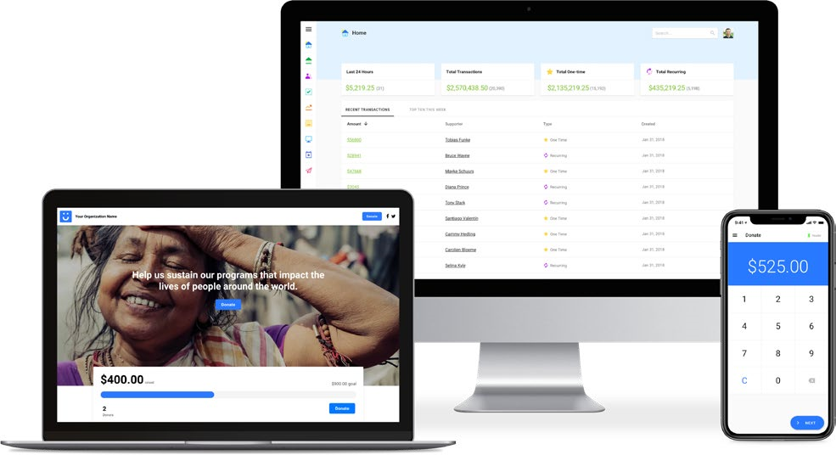

Smart fundraising tech for forward-thinking nonprofits.

[Peer-to-Peer Fundraising](https://funraise.org/peer-to-peer-fundraising)[Donation Tasks](https://funraise.org/donation-tasks)[Wealth Screening](https://funraise.org/wealth-screening)

[Funraise App](https://funraise.org/reader)[Donation Analytics](https://funraise.org/donation-analytics)

[Recurring Giving](https://funraise.org/recurring-giving)[Donation Pledges](https://funraise.org/donation-pledges)

**SAVE THE DATES**

The 2021 Global NGO

Technology Survey will be

released

**March 1, 2021.**

The 2021 Global NGO

Technology Report will be

released

**September 15, 2021.**

**#NGOTECH1**

[**9**](https://twitter.com/hashtag/ngotech19)

[**T**](https://funraise.org/techreport)

**FUNRAISE.ORG/TECHREPOR**

**Thank you to the**

**,721 NGOs worldwide**

**5**

**that participated in**

**the 2019 Global NGO**

**Technology Survey.**

**Your contribution is greatly**

**appreciated.**

**DESIGN BY**

[**M**](https://www.bureauforgood.com/)

**BUREAUFORGOOD.CO**

**SPONSORED BY**

[**G**](https://funraise.org/)

**FUNRAISE.OR**

**PRODUCED BY**

[**M**](https://www.nptechforgood.com/)

**NPTECHFORGOOD.CO**