

Working out your CLC innovation profile
‘Building Digital Capacity’ resources series



This resource is licensed by Community Legal Centres Queensland Inc under a Creative Commons Attribution-ShareAlike 4.0 International (CC BY-SA 4.0). To view a copy of this licence, visit https://creativecommons.org/licenses/by-sa/4.0/.

Resource type: | Strategic area: | Use it to:
Brainstorming exercises on technology innovation |  | - Discuss technology and innovation in your centre.  - Identify possible challenges and opportunities related to technology innovation.
Current as of February 2020
Contents

1 | WHAT DOES INNOVATION LOOK LIKE IN YOUR CENTRE?
2 | WHAT DOES INNOVATION MEAN TO YOUR CENTRE?
3 | WHAT IS YOUR CENTRE’S RISK APPETITE FOR TECHNOLOGY INNOVATION?
4 | WHAT ARE YOU PREPARED TO RISK WHEN IT COMES TO TECHNOLOGY INNOVATION?

Other relevant resources in our Building Digital Capacity resources series:
- LegalTech: useful sources for sector trends and insights
- Applying for funding: technology & innovation guiding principles.

1 – WHAT DOES INNOVATION LOOK LIKE IN YOUR CENTRE?
Innovation is defined as the introduction of something new, like a new idea, method, device, product or service. Innovation is not the same as technology, but the two often go together, as typically technology will be an enabler of innovation (i.e. a way to put innovation into practice).
The 10 questions below are designed to help you ‘get a pulse’ on what innovation currently looks like in your CLC and prompt conversations with your teams. You could use these questions in a quick survey, or as part of a group discussion.
Answers that tend towards ‘no’ or ‘somewhat’ will indicate that innovation is a not (yet) a key area of focus for your centre and can inform a discussion on whether it should and could.
 | No | Somewhat | Yes
- Is innovation seen as a priority for your centre?
- Do you think there is a good understanding across your teams about innovation in the legal sector and its potential ramifications (positive and negative) for CLCs?
- Is innovation a regular topic of discussion for your management committee/board and leadership team?
- In practice, does your centre encourage innovation and support innovative ideas?
- Has your centre identified key areas of operations or services where it needs to innovate?
- Has your centre undertaken innovative projects or have plans to do so?
- Does you centre keep up-to-date on innovation and technology in the legal sector? (e.g. member of LegalTech / innovation working groups, conferences, seminars, etc.)?
- Does your centre have capacity (resources, skills, time, funding) to dedicate to innovation?
- Does your centre partner or engage with external organisations on innovation projects?
- Do you know where to find resources about technology innovation for the legal sector?

2 – WHAT DOES INNOVATION MEAN TO YOUR CENTRE?
In practice, innovation can mean very different things to different people and organisations, and as a term, it is used (and overused) in different kinds of situations. For some, being innovative involves coming up with dramatically new ideas, and bringing significant disruption to old business models. For others, innovation is about changing the way we do things to make them better.
There is a wide consensus that the legal sector is ripe for disruption, with legal innovation at the centre of developing and improving pathways for access to justice and delivery of legal services.
As a CLC, it’s important to work out what innovation means to you so that you don’t try to innovate for the sake of it, but rather because it aligns clearly with your centre’s strategic direction.
The diagram overleaf shows an innovation ‘spectrum’, ranging from no appetite for innovation, to developing radically new and innovative ideas. Use this as a prompt to discuss with your teams where you see you centre:
- Where would you position your centre now?
- Where would you like your centre to be?
- Can you think of other organisations to place on each stage of the spectrum (either in the legal sector or outside)?
- Consider your organisational culture and its natural fit with innovation: not everyone needs to be ‘radical’ to be innovative.
- In practice, how does this translate for your centre?
- What kind of technology-related / innovative ideas or opportunities do you see your centre undertaking (now or in the future)?

3 - WHAT IS YOUR CENTRE’S RISK APPETITE FOR TECHNOLOGY INNOVATION?
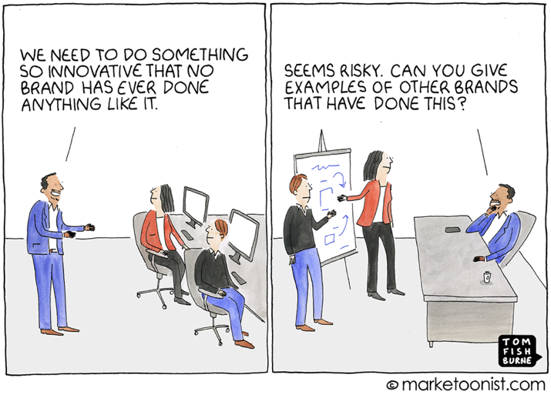
Innovation is first and foremost about change, and it is inherently tied to risk-taking. This can be the greatest barrier for centres to pursue innovative ideas. A centre may be eager to innovate, yet hindered by the ability to take on risks.
Use the quadrant below to place your centre:
- To what extent is your centre willing to innovate through technology (horizontal axis)?
- How would you qualify your centre’s risk appetite (vertical axis)?
- The ‘ideal’ position is in the top right corner: a high desire to innovate through technology together with a willingness to take risks
- What would be required for your centre to get to the ideal position?
- How will that influence your ability to innovate in practice?

4 – WhaT ARE YOU PREPARED TO RISK WHEN IT COMES TO TECHNOLOGY INNOVATION?
As with any new initiative, risks need to be evaluated upfront, with appropriate mitigation strategies identified. Use the table below to identify what your centre is willing to risk when taking on technology/digital innovation:
- Which risks areas are particularly sensitive for your centre?
- In practice, what could happen, and how would you mitigate a particular risk area?
- Are there other risks you should consider for your centre?

 | Yes | To some extent | Never
Time/effort
Financial resources
Brand/reputation
Clients services
Culture/staff engagement
Other
Technology & Innovation Guiding Principle #4: Innovation-ready, risk-prepared
For help on addressing risks for new technology projects, refer to the Applying for funding: technology & innovation guiding principles in our Building Digital Capacity resources series.
Addressing risks as part of technology innovation is critical, and needs to occur across the innovation cycle, from the idea stage all the way to post implementation:
- acknowledge risk upfront and what you are willing to/not to risk;
- assess risk level and identify mitigation strategies;
- get support from your leadership team and management committee/board, and prepare for failure;
- learn from failure and feed what you learned into the next innovation project.

