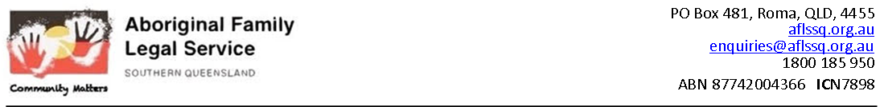

Solicitor: 12 months Contract with flexible work arrangements.

QLD

* **Exciting opportunities for experienced Solicitor to work within a growing legal practice!**
* **Attractive remuneration of $80k for the Solicitor to work out of Toowoomba satellite office.**
* **Enjoy a wide range of benefits including Flexible work arrangements, travel, accommodation, and meal allowances, negotiable with the right candidate!**
* **Enjoy high levels of job satisfaction in a senior role making a true difference in the lives of disadvantaged people!**

**About the Organisation**

The *Aboriginal Family Legal Service Southern Queensland* (AFLSSQ) is a Community Legal Centre and referral service offering legal advice, representation and advocacy to Indigenous victims of family violence in the communities of Charleville, Cherbourg, Cunnamulla, Goondiwindi, Mitchell, Murgon, Quilpie, Roma and St George.

AFLSSQ offers assistance to Aboriginal and Torres Strait Islander people who have been affected by family or domestic violence.

**About the Opportunity**

The *Aboriginal Family Legal Service Southern Queensland* (AFLSSQ) is seeking a passionate and experienced **Solicitor** to supervise and direct their legal practice. This role is a contracted till June 2022 and involves regular travel throughout the Southern Queensland region.

In addition,

Reporting to the PLO and CEO, you will ensure **the legal practice fulfills AFLSQQ's strategic and philosophical goals, by coordinating the development and implementation of casework, intake, community legal education and law reform work.**You will **work with various family cases, managing cases for existing clients,** **as well as seek out new clients to assist in organisation growth.**

More specifically, your daily contributions will include (but will not be limited to):

* You will undertake work by the service in Family, Child Protection and Domestic Violence, Witness Assist;
* Ensuring a high quality of assistance and providing professional support to all legal, paralegal and volunteer legal staff;
* Ensuring your practice in compliance with all relevant legislative and regulatory requirements;
* Contributing to the preparation of statistical and other reports regarding the operation and development of the legal practice; and
* Undertaking appropriate professional development activities to maintain and enhance your knowledge and skills.

**About You**

To be considered for these role, you must hold a relevant tertiary qualification, including Bachelor of Laws or equivalent. You will also require admission (or the ability to be immediately admitted) as a Legal Practitioner or Barrister of the Supreme Court of Queensland and the High Court of Australia, along with being eligible to hold a Unrestricted Practicing Certificate. You'll also have successfully completed a Graduate Diploma in Legal Practice or equivalent, with strong post admission experience.

You will have broad general knowledge of and demonstrated experience in the areas of family law, domestic violence and child protection, and will be sensitive to the issues facing Aboriginal and Torres Strait Islander victims and survivors or family violence, in particular women and children.

*AFLSSQ* is seeking organised, empathetic, motivated and driven self-starters, with a strong commitment to social justice. The ability to multitask within a high pressure environment will be essential to your success in this role.

Importantly, you'll be a strong and versatile communicator with strong time management and organisational skills. You'll have a demonstrated ability to work autonomously and collaboratively within a team environment. Your well-honed interpersonal skills will enable you to liaise and network within the local community and develop professional relationships with internal and external stakeholders.

A current open driver's licence, an ability to work flexible hours and the willingness to travel extensively are also required for this role. A current First Aid Certificate will be highly advantageous, but is a not a requirement in this role.

Whilst not essential, experience in an Aboriginal or Torres Strait Islander governed community organisation, along with knowledge of the Community Legal Service Information System and Microsoft Excel would be highly regarded.

**About the Benefits**

This is a fantastic opportunity to change lives and truly help people who are struggling, and to see the results of your hard work first hand! The **Solicitor will be offered an attractive base salary of $80,000** based on skills and experience,

With an open-minded management team, ideas towards growth and change are always welcome.

Email: [Tabatha.Young@aflssq.org.au](mailto:Tabatha.Young@aflssq.org.au) or 0438113484

Applications Close: 5pm, Friday 23rd July 2021.