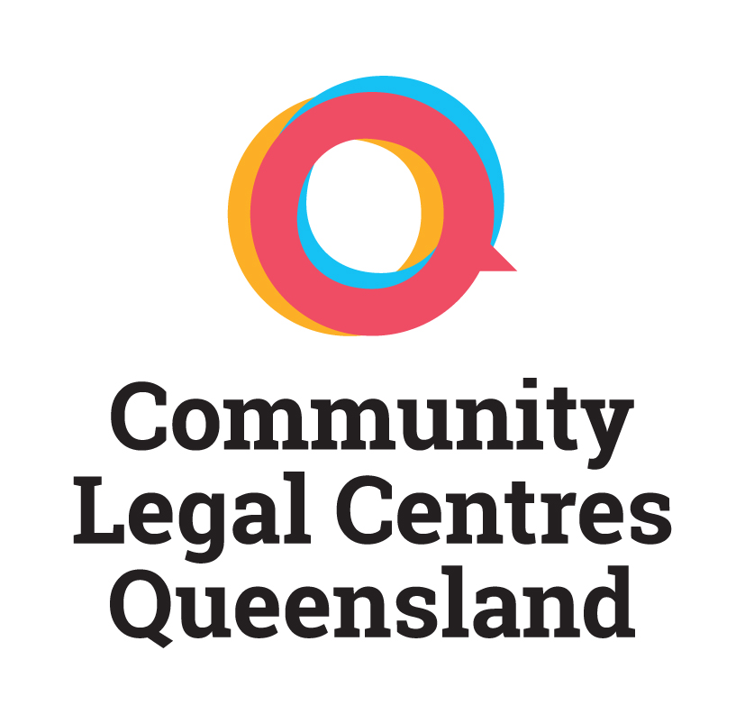

**2021 LEADERSHIP FORUM**

**Travel subsidy**

The annual Community Legal Centres Queensland Leadership Forum is one of the premier events in the community legal centre calendar. The Leadership Forum is an opportunity to develop and strengthen staff member skills, increase their knowledge base and network with people working in the field.

Community Legal Centres Queensland has allocated funding to bring community legal centre staff to the workshop in Brisbane. The amount available is $300 per centre and can be used for travel or accommodation. Only centres outside of Brisbane may apply. Community Legal Centres Queensland will allocate the funding by taking into account distance travelled and the the number of applications received.

To apply for the funding please complete details below and return to Community Legal Centres Queensland by post or email. If your centre is selected for funding you will then be asked to send Community Legal Centres Queensland an invoice for $300 and submit receipts within one month of the workshop taking place. The deadline for submitting applications is **10 November 2021.**

|  |  |  |
| --- | --- | --- |
|  | **DETAILS** | **COST** |
| **Organisation** |  |  |
| **Contact Person** |  |  |
| **Telephone** |  |  |
| **E-mail** |  |  |
| **Forward journey date & time** |  |  |
| **Return journey date & time** |  |  |
| **Travel details: e.g. from** |  |  |
| T**ype of travel: e.g. flight, car** |  |  |
| **Name and address of accommodation provider:** |  |  |
| **TOTAL COSTS** |  |  |

Please forward this form by email to Louise at [communications@communitylegalqld.org.au](mailto:communications@communitylegalqld.org.au)

Post to: PO Box 12102 George Street, Brisbane QLD 4003. For further information phone 07 3392 0092.